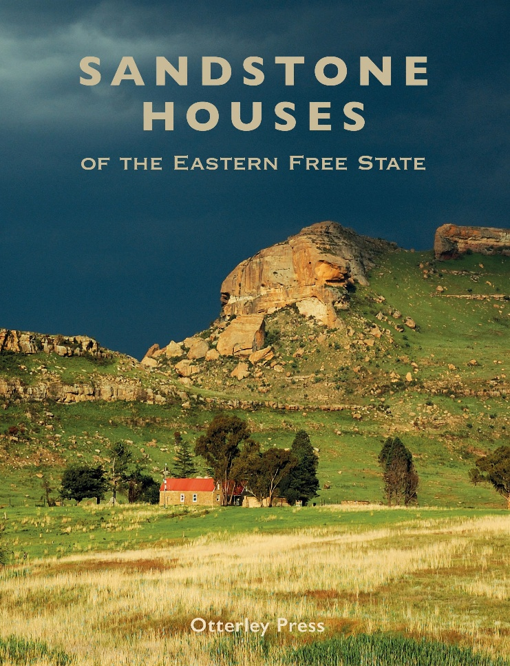 **Sandstone Houses of the Eastern Free State**

**by Otterley Press**

ISBN: 9781776447350

Price: R780

Trade Paperback 320 pages

280mm x 215mm

Publication Date: July 2025

Publisher: Otterley Press

Discover the timeless beauty and architectural heritage of the Eastern Free State in this superb, multilayered book from Otterley Press. In 320 pages of informative text and striking images, *Sandstone Houses of the Eastern Free State* takes readers on an enchanting road trip through the region.

*Sandstone Houses of the Eastern Free State* will take the form of a road trip through the Eastern Free State, commencing in the Swinburne/Harrismith area, then moving to Clarens, Fouriesburg and on to Ficksburg, Ladybrand, Tweespruit, Wepener, Clocolan and Zastron, as well as to lesser-known villages and settlements in the area.

Richly illustrated, and featuring a variety of houses, including some very small cottages dating back to 1830, the book will take you on a tour of this glorious countryside where sandstone cliffs bask in honey-gold hues. Each chapter offers insights into the craftsmanship, historical significance and family stories associated with the remarkable sandstone houses scattered across a rugged landscape.

The quarries in Fouriesburg, Ladybrand and Ficksburg provided the stone for these unique houses and, even today, the stone is carved using the same techniques that were employed a hundred years ago. The sandstone utilised in the building of the houses – which range from small to legendary – is known for its distinctive character and high quality. The houses, chronicled by examining both the architecture and the stories of people who lived in the homes (for the two are intertwined), is written by local experts in each area.

As time moves on many of these dwellings are falling into disrepair, with the potential loss of their legacy. The historical record of a selection of houses is preserved within the pages of this book.

**About the Contributors:**

Contributors include Gideon Groenewald, a paleogeologist; Kobus du Preez the heritage architecture lecturer at the University of the Free State, Professor Kathy Munro, University of the Witwatersrand, President of SA Heritage and Vice Chairman of the Johannesburg Heritage Association, among many others.