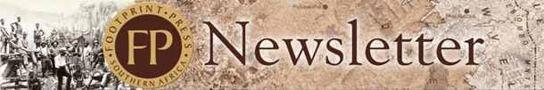
Launched at the National English Literary Museum in July
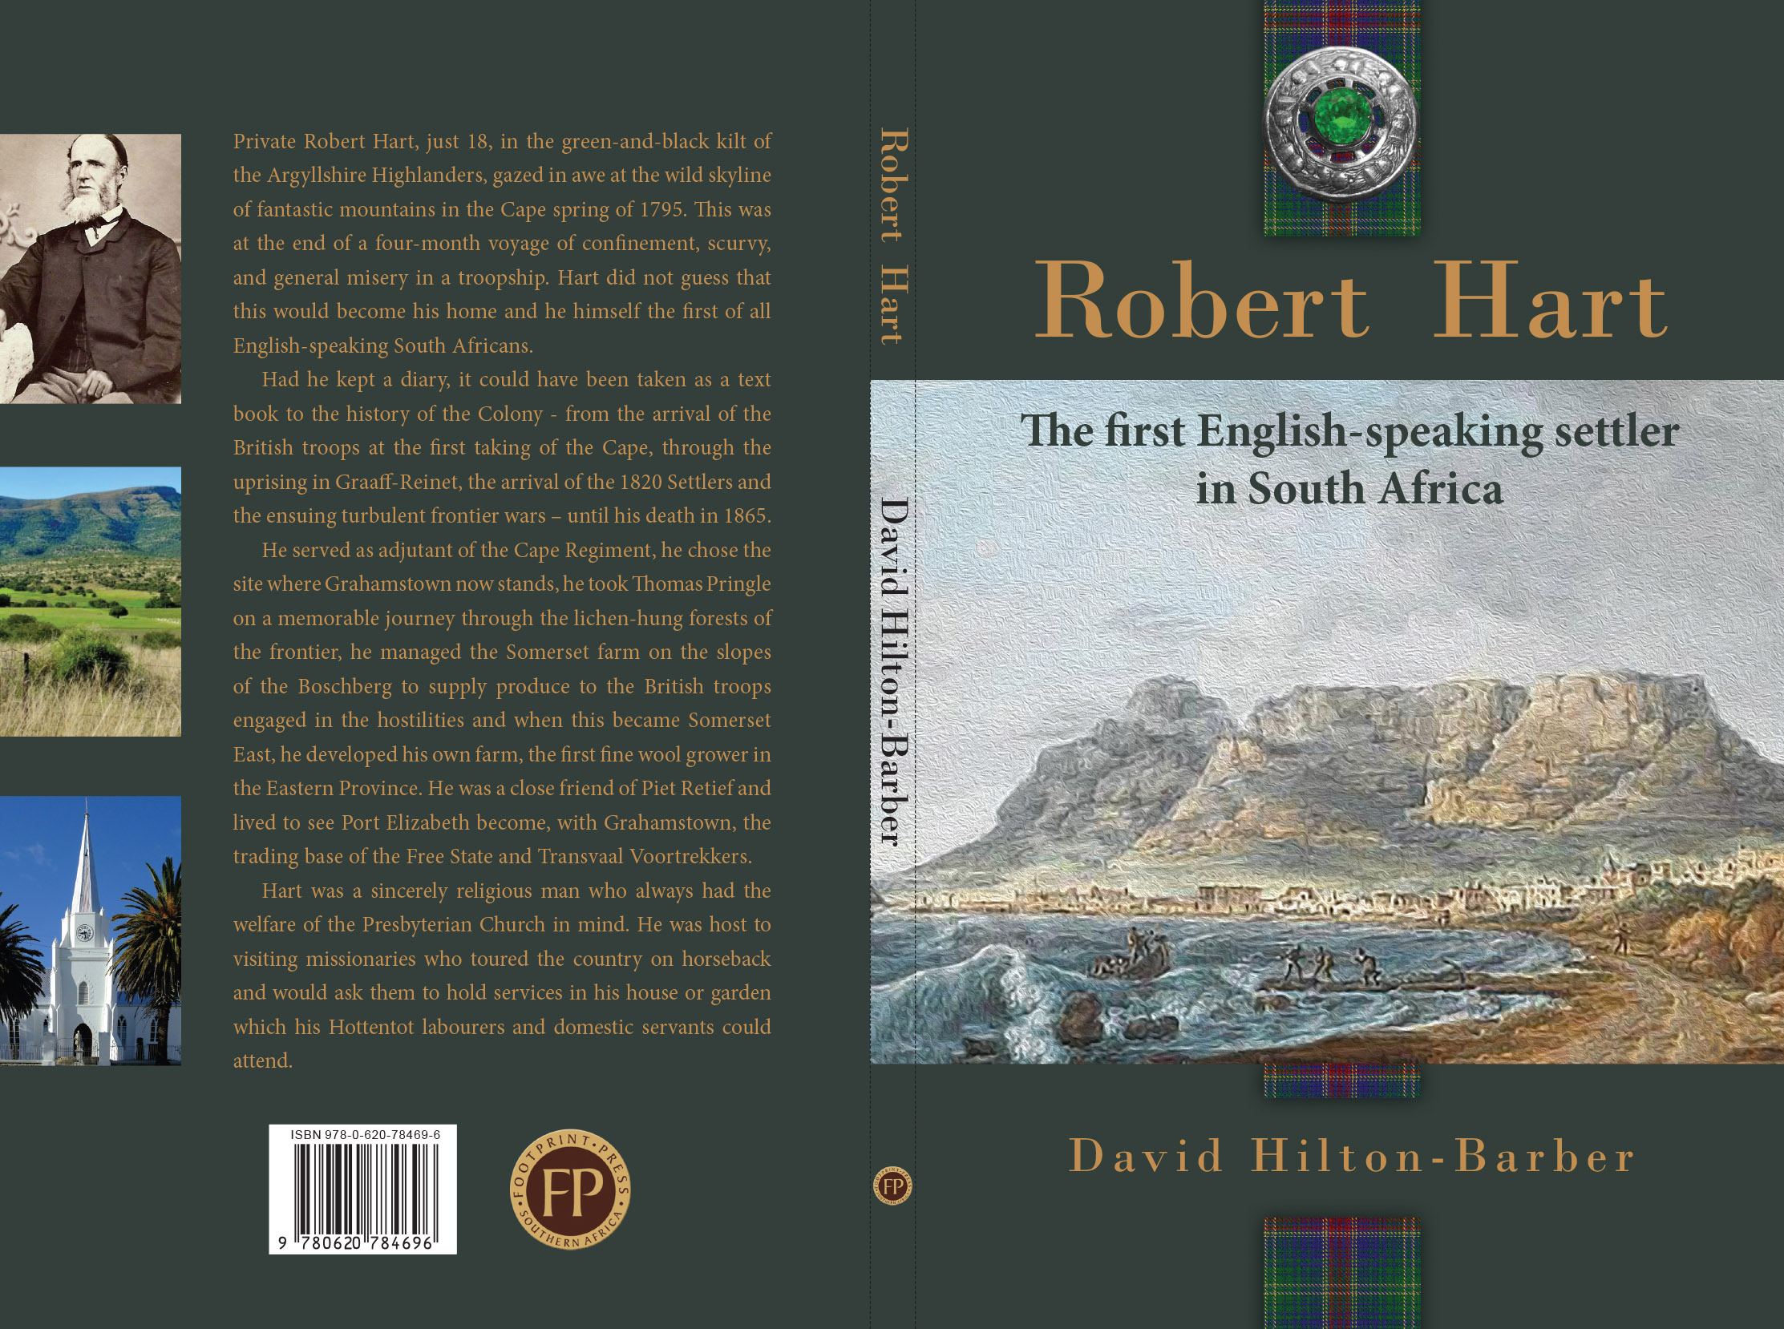
Robert Hart, the first English-speaking settler in South Africa
The life of Robert Hart was contemporaneous with the whole history of the Cape Colony under British rule, and to write a complete history of his life would be to write, in a, great measure, a history of the colony. Had he kept a diary, it might not only have been interesting and instructive, but could have been taken as a text book to the history of the Colony, as he came to the Cape in the year 1795 with the British troops under Sir Home Popham, and was at the first taking of the Cape.
(John Bond (They Were South Africans, Oxford University Press, 1956): The name of Robert Hart is almost unknown. That is strange because Hart, as far as I can discover, was the first English-speaking South African. He came to South Africa in its darkest period when the Dutch East India Company's rule was breaking down completely. His whole life, from the day he landed in 1795, was devoted one way or another to shoring up the shaky structure of the Cape.)

Private Robert Hart, just 18, in the green-and-black kilt of the Argyllshire Highlanders, gazed in awe at the wild skyline of fantastic mountains in the Cape spring of 1795. This was at the end of a four-month voyage of confinement, scurvy, and general misery in a troopship. Hart did not guess that this would become his home and he himself the first of all English-speaking South Africans.

Had he kept a diary, it could have been taken as a text book to the history of the Colony - from the arrival of the British troops at the first taking of the Cape, through the uprising in Graaff-Reinet, the arrival of the 1820 Settlers and the ensuing turbulent frontier wars – until his death in 1865.

He served as adjutant of the Cape Regiment, he chose the site where Grahamstown now stands, he took Thomas Pringle on a memorable journey through the lichen-hung forests of the frontier, he managed the Somerset farm on the slopes of the Boschberg to supply produce to the British troops engaged in the hostilities and when this became Somerset East, he developed his own farm, the first fine wool grower in the Eastern Province. He was a close friend of Piet Retief and lived to see Port Elizabeth become, with Grahamstown, the trading base of the Free State and Transvaal Voortrekkers.

Hart was a sincerely religious man who always had the welfare of the Presbyterian Church in mind. He was host to visiting missionaries who toured the country on horseback and would ask them to hold services in his house or garden which his Hottentot labourers and domestic servants could attend.

RRP: R240.00 + Free Delivery
ISBN 978-0-78469-6
Size: 234 x 153 mm
Text: Text: 130 pages + 4pp Cover

Name: …..……………………………....……………………………....……………………………..
Delivery Address: ..…………..……………………………..…………………………………………
..………………………………..……………………………..…………………………………………
No. of copies: …………
Your Order No. .………………………………..
PLEASE EMAIL THIS ORDER FORM TO: david@hiltonbarber.co.za
Mobile 083 380 3262
Landline 028 316 2783

