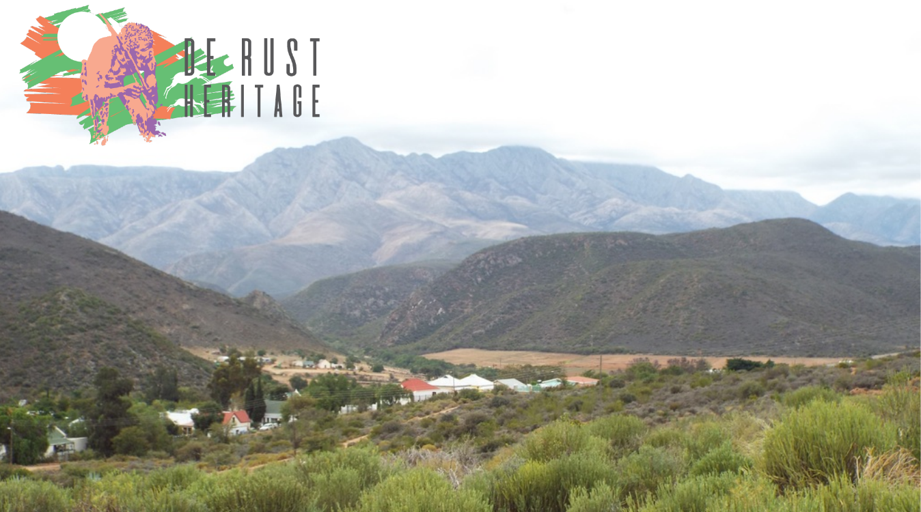
Notes of the Meeting between HWC and Heritage Structures
Located in the Southern Cape & Klein Karoo Region
Held at the George Museum on 18 June, 2019

These notes are not minutes of the meeting but cover the various points from the agenda as presented by Heritage Western Cape for general discussion.

These notes should also be read in conjunction with the Notes for the Meeting presented by De Rust Heritage to be discussed by the HWC Council:

Introduction: Ms Colette Scheermeyer the Director of HWC apologised for the absence of Dr Mxolisi Dlamuka the CEO of Heritage Western Cape who had been called to a meeting in Pretoria at short notice.

She also provided a background to the HWC intentions to reach out to the various regions in the Western Cape as expressed by Dr Dlamuka in December, 2018 at the meeting in Oudtshoorn (see www.derustheritage.org.za under Klein Karoo Heritage Forum). It was also mentioned that HWC was resource scarce in terms of both budget and staff requirements and needed to look at how best to service the heritage requirements of all communities in the Western Cape including the more rural areas of the Province.

In conclusion, there was a brief explanation of how Heritage Western Cape recognised the need to be able to offer a professional service to all the regions in the Western Cape, even those outside the direct area surrounding Cape Town, Stellenbosch and the Drakenstein/Paarl region.
Matters of Regional Concern:
Following the introduction by the Director of Heritage Western Cape the major points flowing from the agenda were as follows:

HWC Permit Applications: Ms. Scheermeyer explained that in the last year HWC had handled around three thousand (3 000) permit applications – an average of 250 per month. The question was then raised how many of these were Grade 3 level applications which should really be handled by the local municipalities and registered heritage bodies who were in many cases better placed to handle these and had the resources to do so?

It was agreed that not all local municipalities had the capability to handle Level 3 applications and in those cases HWC would still need to be involved. However, in the case of better resourced municipalities the principal of regular audits would be a logical way of checking on correct processes being followed.

The above approach for those capable of handling this approach such as the Greater Oudtshoorn Municipality in conjunction with the registered heritage bodies - Heritage Oudtshoorn Erfenis and De Rust Heritage. This would reduce the chance of permits being incorrectly issued by HWC which had already been turned down on sound grounds by the Joint Permit Committee in Oudtshoorn.

Enforcement: There was a discussion around enforcement of contraventions of the National Heritage Resources Act and it was admitted that HWC had neither the resources, will or ability to enforce contraventions – particularly in the more far flung areas of the province.

Following discussion there was broad agreement that enforcement at local level was possible by municipalities broadening the scope of their by-laws to accommodate contraventions. This could be done relatively quickly and would ensure that offenders would be handled both speedily and effectively.

This approach would also ensure that local communities would be closer to seeing and understanding the law in terms of contraventions through their Building Control Officials who are on the ground on a regular basis.
In this regard De Rust provides an excellent case study of local management co-ordinated efforts on the ground between the Building Control Officials in Oudtshoorn, De Rust Heritage and the Joint Permit Committee which meets every second week in Oudtshoorn.

Competence: The view was expressed by the Oudtshoorn representatives that the Greater Oudtshoorn Municipality through its existing structures was capable of managing all Grade 3 level applications at the local level.

It was agreed that the Legal Advisor of HWC would send the necessary documentation for a competence assessment by Heritage Western Cape to the Oudtshoorm Municipality as well as copying the two registered heritage bodies Heritage Oudtshoorn Erfenis and De Rust Heritage.

Heritage Surveys & Inventories: As a follow-up the question of heritage surveys and inventories was raised and the view was expressed that in the case of most local municipalities the costs of such an exercise were out of reach. In the case of Stellenbosch and Paarl (the Drakenstein Municipality) private funding was available. However, for the large majority of smaller rural municipalities this is not an option. In this regard I refer to the De Rust Heritage website under Heritage Inventories where we have links to both Stellenbosch and Greyton as examples of both large and smaller surveys.

There was also discussion around the inventory conducted in De Rust some years ago by the University of Port Elizabeth (now Nelson Mandela University) under the direct supervision of Prof Franco Frescura. It was suggested that this could be submitted as a first step towards compiling a more detailed and updated inventory in the future.

Community Sustainability: There was also discussion around the issue of community sustainability linked to heritage conservation. The view of De Rust Heritage is that unless community sustainability is present then efforts made in preserving heritage will fail. Communities have to be successful in order for the heritage part of the equation to be fully integrated into the “Hearts and Minds” of those living and working in that community environment.
The Issue of Values: Values are often quoted by people at all levels of society but are seldom really understood – most people who quote “values” often believe that all should share their value system. This is not the case as seen below quoting from the work of Prof Clare Graves and Dr Don Beck.

Equally, the issue of “heritage” is seen differently at different stages on the values spectrum. As an example a person who is battling just to survive is certainly not going to be interested in anything “heritage” and may in fact be part of destroying rather than building heritage just to stay alive.

- Values of Existence: Staying Alive at all Costs
- Values of the Tribe: The Tribal Order and Good of the Tribe - Ubuntu
- Power Now Values: I want “Power Now” not later
- Values of Stability: Building a Stable Safe Society for All
- Values of Enterprise: Innovation/Industry and Success
- Green Eco-Values: Saving the Environment and Our World
- Integrated Global Values: Understanding the Whole World Mix

Each individual globally is a mix of a number of the above values and the predominant value in their mix is how they will in all probability react. The question of values and change are critical in terms of the individual worldviews and how each person sees their world and manage change. It is important to note that no single value or mix of values is better or worse than others – it is how to best manage these constructively for the improved welfare of all.

Based on the above research over more than 70 years, there is significant real world evidence to show that in South Africa in particular we have the “full mix” of values which are not always evident in many other countries. Based on this we need to carefully consider how to tackle many important issues including heritage. Heritage will succeed or fail depending on the understanding of how to manage the “values mix” present in our community, region or country.

Understanding values is the key to building sustainable communities at both the micro and macro level. This in turn results in successful communities, regions and countries with positive values being in the majority.
Other Issues Covered:

Education: Nelson Mandela is quoted as saying, “Education is the most powerful weapon which you can use to change the world.”

Heritage education at all levels should be part of the educational curriculum in both schools and tertiary institutions covering the full range of values present in a society. A better understanding of heritage issues will lead to better inter-personal communications at all levels of the population.

Stories: We at De Rust Heritage believe that stories are part of the fabric of our community and environment. To this end we have a section on our website called “De Rust & District Stories” where we are in the process of documenting those still available where there are still people alive who can recount these tales for posterity.

Stories are part of the fabric of our society and we are also attempting to obtain other stories from the distant past which have been passed down from individual to individual by word of mouth over the generations.

Historic Mountain Passes: The issue of the upkeep and preservation of both the Swartberg and Montague Passes was raised. This related particularly to the responsibility for these heritage assets and why under current circumstances the issue did not appear to be a fully integrated part of the current Provincial Governments Management Plan.

Mission Stations: There was discussion around the current preservation status of Mission Stations. It was explained that in many cases the mission stations were owned by the various religious organisations and as such it was difficult to ensure that preservation always took place in terms of the Act.

There being no further items for discussion the meeting closed at 17h00.

De Rust Heritage
19 June, 2019

