GENERAL COMMENTS ON THE PROPOSED ROSEBANK TOWERS DEVELOPMENT IN THE CONTEXT OF THE ROSEBANK LINEAR PARK

1.0 INTRODUCTION

In 2011 the City of Johannesburg (CoJ) promoted the concept of a Linear Park for Rosebank. This was intended to replace a number of public spaces in the area and lend to them a particular identity and amenity that, singly, they did not possess.

“Linear” means “going from one thing to another in a single series of stages”. “Single” means “only one”. Thus it was reasonable to conclude that the Linear Park prescribed for Rosebank would unify the random spaces linked by servitudes and give them a single identity.

Years later, after nearly an eight year gestation period, The CoJ has delivered a brief which delivers a monstrosity, deformed by essential parts of it missing. There is no explanation for this. Instead it concentrates on parts of the creature, as though by that device the missing parts will go by unnoticed.

The CoJ has commissioned Heritage Consultants to prepare a Heritage Impact Assessment (HIA) on the impact of the demolition of the present Rosebank Library and the Rosebank Clinic [a structure built more than sixty years ago and protected by Section 34 of the National Heritage Resources Act (NHRA)].

The existing library conformed to the standards of the time but the demographics of patrons and their needs have changed. Accordingly the structure is said to be outmoded.

2.0 INADEQUACY OF THE BRIEF

- Purpose of Libraries and Clinics:
The brief does not instruct the consultants to consider the purpose of parks and libraries in the 21st Century. It seems that parks are regarded as pieces of land with trees, left over when land on which private development is expected, and libraries are places where books are stored and borrowed. However such descriptions are hopelessly inadequate. Both have evolved to have complex social functions that reflect modern societal needs.

- Permeability through public servitudes:
The proposal fails to engage with existing town planning, urban design, social and economic and heritage issues in a realistic or holistic manner. Nor does it recognise the debt of gratitude to earlier town planners and urban designers who established servitudes that permitted pedestrians (members of the public) to move over privately owned property by vesting legal servitudes, in the public’s name. These were intended to move pedestrians from Jan Smuts Avenue to Oxford Road in pleasant, open air surroundings. This was not a mere gesture of permeability but part of a system to engender greater mobility and enhance the amenity of Rosebank.

Furthermore past policy reveals a caring for the public welfare of ordinary citizens and a generosity of spirit on the part of early City Councils because the servitudes must have increased costs at the time. This expenditure is to be sacrificed if the expedient lack of attention to servitudes in the present proposal is anything to go by.

This minimises the importance of the desired social and environmental characteristics of the parks and the linkages between them, and gives priority to commerce and profit for those with vested interests.

Worse still, it ignores the heritage implications, or is ignorant of the inheritance afforded by the foresight of previous generations, namely the pedestrian system. It is particularly silent as to the environmental impact on the Linear Park when it is implied that servitudes may be taken through basements or private properties, and are merely access points.

- No recognition of the importance of the social amenities of Library, Clinic and Park:
The project description on Page 2 of the Background Information Document (BID) states that the building would consist of:

- Ten storeys and two basements
- Retail space including a new library, coffee shop and day clinic
- Office space
- Residential area
- Parking area with 352 parking bays
- Store room area

There is no mention of:

- The social functions of the library or clinic which seems to be referred to under the heading of Retail Space (revenue-producing for the developer);
- The location of the library and clinic. They could be situated in the basement, on the tenth floor or remote from the Park;
- The symbiotic relationship of the library and the clinic with the EWJ Park that has been reduced to little more than a pedestrian movement strip;
- The social amenities that the EWJ Park should aspire to;
- The interruption of the movement channel where it meets the western boundary wall of the extension to the Mall of Rosebank.
IAPS are required to make comment on a proposal made in a vacuum of disinformation to demolish a perfectly serviceable structure, on CoJ-owned property in order to replace it with a ten (10) storey commercial structure and then to provide a library and clinic somewhere within it. No compensation is mentioned for the social amenity that will be lost to the community.

- Low Priority given to Library and Clinic in the Accommodation Schedule:
The Schedule of Accommodation for the new structure given is listed above under (3).
There is no mention of a library and clinic. This has been added later when it was decided not to indulge the users by providing a separate library building in proximity to the Linear Park.

When added to the accommodation schedule, the Library/Clinic is given no priority rating above other facilities in the multi-story structure. It could, in terms of social amenity, be ranked no higher than a storeroom in the hierarchy of spaces.

The location of the social facilities could be at the owner’s discretion and security of tenure is not mentioned.

- Inadequacy of the HIA: The inadequacy of the brief must result in the inadequacy of an HIA.

- The HIA in the Context of the Linear Park:

When the Rosebank Linear Park scheme was mooted in 2011 the concept enjoyed the support of IAPs.

The development of the Linear Park, as planned, is expected to change and enhance the configuration of the open public space in Rosebank.

The Library/Clinic exists on a separate site (Erf 1/136 and Erf Re136). The proposal requires its demolition. This calls for a heritage impact assessment (HIA) in terms of the NHRA.

It is appropriate to examine the demolition of the Library and Clinic in the context of the Linear Park and what this will do to the original concept as first proposed. The Linear Park Scheme (See Diagram 1 below), however, has not yet been approved by the CoJ.

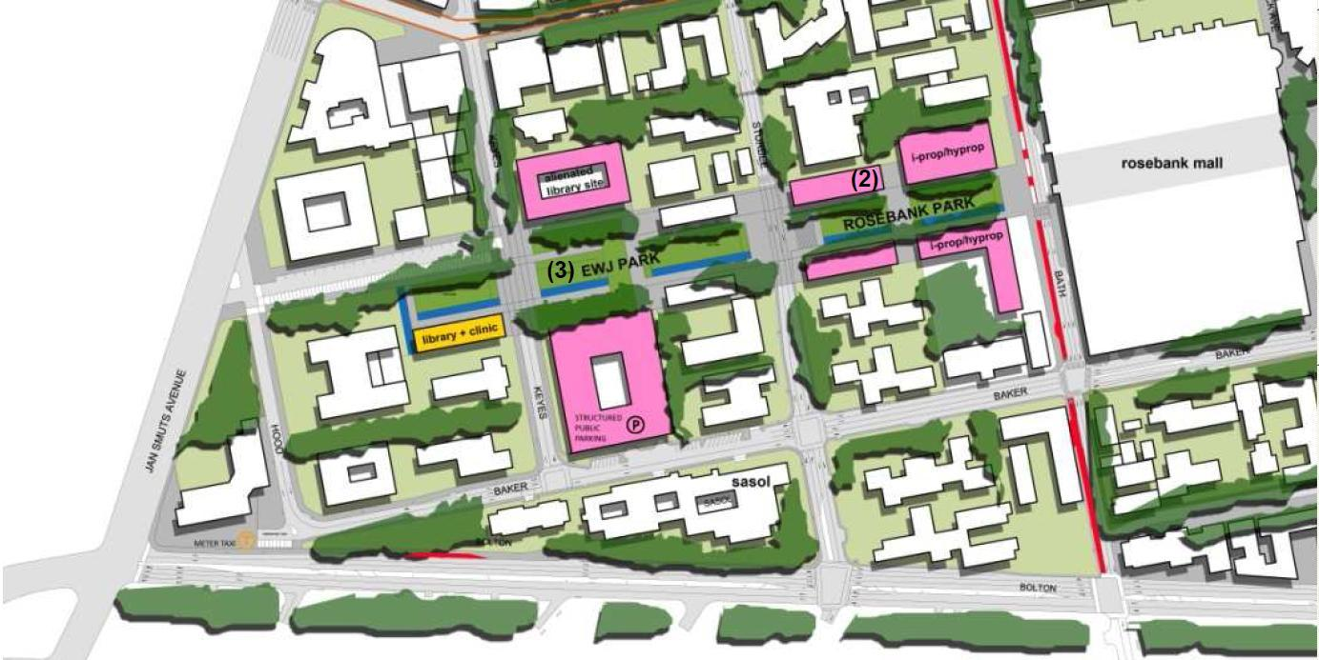

Diagram 1 – Rosebank Linear Park 2011

The redevelopment of the library and adjacent Park is part of the greater “Rosebank Linear Park” scheme that should consider the upgrading of existing network of parks and public access routes that currently exist in Rosebank.

- When is this to be done, and when is it proposed to consider the impact of the demolition of the Library/Clinic on the Linear Park and vested community interests?

- An HIA should be considered in the context of the Rosebank Linear Park in a holistic and comprehensive manner.

3.0 LOCATION OF THE ROSEBANK TOWERS BUILDING

The Rosebank Towers building would appear to be located on Erf 1/136 and Erf RE136 and it encroaches on Erf RE209 to an unspecified dimension – probably to the southern boundary of Erf 1/131.

The servitude linking the passage from Erf 209 to Bath Road is presently on Erf 1/131. However, a servitude through Erf RE131 is the favoured route. The reason for such a decision is not stated. The park is assumed to be limited to the south face of the structure on Erf RE131.

Diagram 2 – BID document

This means that the site of Rosebank Towers, as compared with the site of the Library-Clinic, is greatly increased. The part of RE/209 on the western side of Keyes Avenue and the southern boundary of the east part of RE/209, would seem to coincide. It should however be noted that this decrease is compensated by using RE/209, on the west side of Keyes Avenue as an extension to the park on the east side.

4.0 SERVITUDES – OPTIONS LEFT OPEN FOR DECISION AT A LATER DATE

On the Rosebank Linear Park document (Diagram 3) servitudes linking Bath Avenue and Keyes Avenue are shown. Which option is finally adopted is not mentioned. The lack of critical information leads to confusion. See Diagram 3 below.
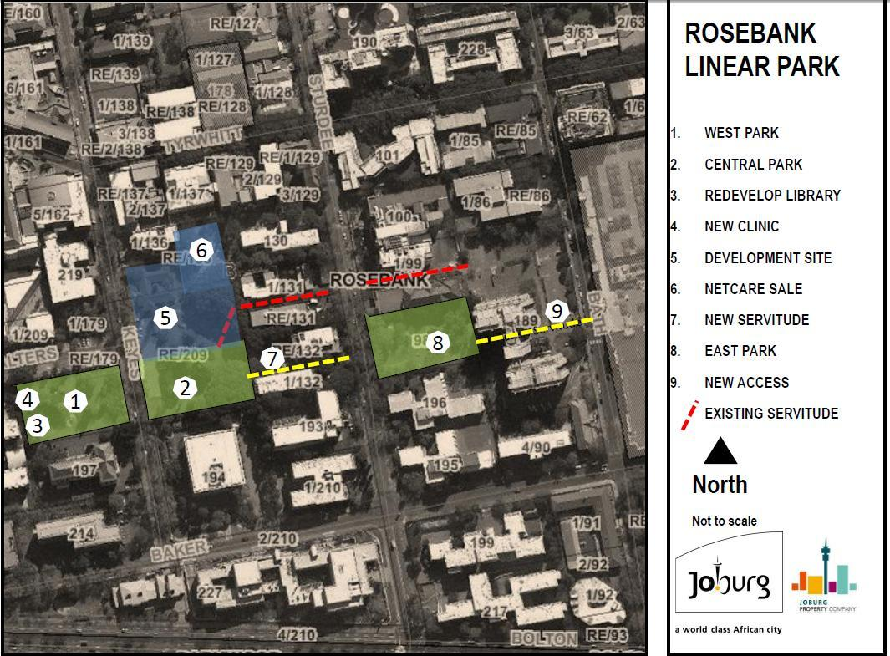
Diagram 3 – Rosebank Linear Park document 2011

Yellow Line:
There is a servitude shown by a dotted yellow line which runs through RE132 and 1/132, crosses Sturdee Avenue, through the park on Erf 98 and then joins an existing servitude over Erf 189 to Bath Avenue. Why is this not the favoured route for the servitude? This lack of transparency is further compounded because the development of a Basement parking on Erf 189 ignored the servitude on Erf 189. There is thus a five and a half metre difference in level between the park and the existing servitude on 189.

- This has been the source of conflict between the RAG, the developer and the CoJ since 2011, but it is not referred to. Nor is it mentioned how this obstacle can be overcome. This, together with the favoured route for the servitude on Erf 1/131, leads to the belief that the CoJ planners favour the red route and are being less than frank about their intentions.

The developer, Hyprop, has tried, unsuccessfully, post facto, to have the ten metre servitude expunged and replaced with the 5 metre servitude through the basement of Erf 189. Their appeal has also been turned down by the Planning Department of the CoJ.

The Park on Erf 98 was always believed to be part of the Rosebank Linear Park development. If the red dotted line applies, this completely misses the Park on Erf 98.

Red Line

There is another servitude shown by a dotted line in red between RE1/131 and RE131.

This is convenient for the Council because there is a proposed parking basement under the park on Erf RE 209 which presumably connects the development site on Erf 194 to the preferred servitude on the north side of Erf RE131. This could readily be diverted to end up opposite Erf 98.

The red dotted line is convenient for the developer, opposite the vehicular entrance either to the parking basement on Erf 189, or the service entrance to the Rosebank Clinic but this could mean that pedestrians would share access to the basement of Erf 189 with vehicles.

It would be expedient if the development of a 5 (five) meter wide servitude in the basement parking garage of Erf 189 should be chosen as the route take for the Linear Park. This would avoid potential conflict with the owner of Erf 189 because of the ambivalent situation that the CoJ finds itself in when it approved a development plan for Erf 189 when servitudes still existed on the land. This made it difficult to access the servitude. Instead of resolving the difficulty that involves some cost, the CoJ seems, by devious means, to want to make the problem disappear. This is to the detriment of the environment.

Notwithstanding that this is presumably what Hyprop would like, it would be in conflict with the notice from Marietjie Reinecke of the CoJ Planning Department dated 12th September, 2017, which stipulates “Such servitude shall be open to the sky, shall be at least 10m wide, shall provide a pedestrian friendly environment and shall provide unhindered access between Bath Avenue and Sturdee Avenue, over Erf 189 Rosebank and the Park located on Erf 98 Rosebank.”

This would be difficult to achieve if the route indicated by the red line is chosen.

The concept of Linear Park is illustrated in Diagram 1 on page 2, but the optional servitudes still remain to be decided. All the options stated are not equally conducive to ambience or in keeping with the concept of the Linear Park in Rosebank.

- The servitude over Erf 189 should be confronted in any HIA.

- IAPs are asked to comment on a development that will affect a Linear Park Scheme, not yet defined, incomplete and not approved yet by Council.
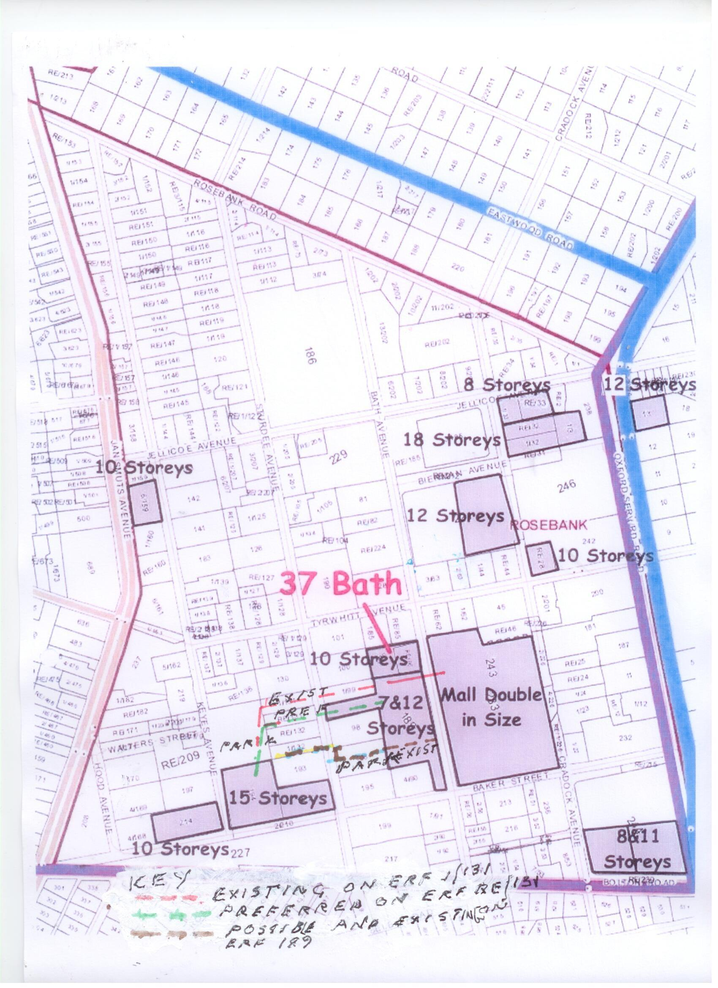

Diagram 4 shows the existing and possible options

5.0 PARKING GARAGES UNDER THE PARKS

In a report on the closure and alienation of part of the Remaining Extent of Erf RE 209 and RE of Erf 136, Rosebank by The Transactions Committee of the Economic Development Sector of the CoJ Property Company Soc Ltd – the need for park in Rosebank is emphasised and underground public parking is proposed under the two parks (Erf RE209 and Erf 98). It should be noted:

A park upon the roof of a structure has drawbacks. These are, inter alia:

- The adaptability to change the planting or redesign the layout of the park is limited to the places where large trees can be planted.

- It is structurally costly because excess loads on the roof of the structure have to be taken into account.

The capital cost is obviously less when land, already possessed by the City, can be used to create public parking places instead of having to purchase expensive land in the open market or by expropriation. This seems to be the motivation behind the CoJ wanting to abandon separate structures to house vehicles, and for land owners to sponsor and maintain parking garages and maintain them together with parks.

- The amenity of the park could be limited by the above factor, especially when structures have to ensure easy gradients at entrance and exit points into basement parking garages.

- Amenity and adaptability are particularly important to ensure that parks are used by the public. However, the needs of the users change with time and with the changes the amenity should adapt to the altered conditions.

This seems eminently sensible but without amenity and adaptability if the public space is not utilized, how logical is it to spend money on facilities, namely the park that may not be used?

- There must be an environmental study with regard to the impact of the underground parking on the parks.

6.0 THE NATIONAL HERITAGE RESOURCES ACT (1999)

6.1 The Demolition of the Rosebank Library and Clinic in terms of the National Heritage Resources Act of 1999 (NHRA)

- Section 38 of the NHRA

In terms of this section: “…any person who intends to undertake a development categorised as—
…(c) any development or other activity which will change the character of a site—
(i) exceeding 5 000 m 2 in extent; or
(ii) involving three or more existing erven or subdivisions thereof; or
(e) any other category of development provided for in regulations by SAHRA or
a provincial heritage resources authority, must at the very earliest stages of initiating such a development, notify the responsible heritage resources authority and furnish it with details regarding the location, nature and extent of the proposed development.
notification in terms of subsection (1)—

(a) if there is reason to believe that heritage resources will be affected by such
development, notify the person who intends to undertake the development to
submit an impact assessment report...”

- Has the relevant heritage authority been notified and, if so, what was their response?

An HIA must include the following:

(a) The identification and mapping of all heritage resources in the area affected;
(b) an assessment of the significance of such resources in terms of the heritage
assessment criteria set out in section 6(2) or prescribed under section 7;
(c) an assessment of the impact of the development on such heritage resources;
(d) an evaluation of the impact of the development on heritage resources relative
to the sustainable social and economic benefits to be derived from the
development;
(e) the results of consultation with communities affected by the proposed
development and other interested parties regarding the impact of the
development on heritage resources;
(f) if heritage resources will be adversely affected by the proposed development,
the consideration of alternatives; and
(g) plans for mitigation of any adverse effects during and after the completion of
the proposed development.

7.0 CONCLUSION

- A Statement of Significance should reflect all aspects of cultural significance as defined in the NHRA. The qualities expected of the Library and Clinic should be included.

- The impact that the new building will have on the ambience of the Park should be comprehensively addressed.

- IAPs are asked to comment on a development that will affect a Linear Park Scheme, not yet defined, and incomplete;

- Clarity is required to establish the distribution of land as part of the Linear Park Development;

- The servitude over Erf 189 should be confronted in the HIA;

- The Library and Clinic should be located at ground level with easy access to the public;

- There must be an environmental study with regard to the impact of the underground parking on the parks;

- The gauging of public opinion is premature and the question is asked:

- What redress do IAPS have if an in-principle agreement is given to a specific proposal and a different option is later chosen?
- Under the circumstances what purpose does it serve to proceed with the present enquiry?

- It is vital that an HIA deal with the concept of Linear Park as a unified and holistic experience.

HERBERT PRINS
HERITAGE CONSULTANT

