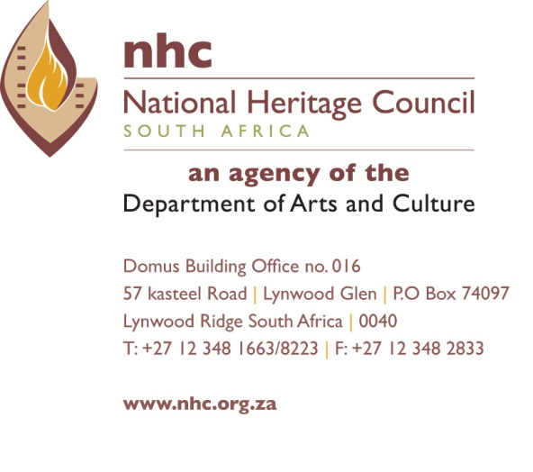

GOLDEN SHIELD HERITAGE AWARDS 2018 – FINALISTS AND WINNERS PER CATEGORY
CATERGORY | NO | NAME AND SURNAME (NOMINEES)
1.National Living Treasure | 1 | Mr Thomas Chauke***** (Winner) (R15 000.00)
 | 2 | Mr Jonas Gwagwa (Winner) (R15 000.00)
2. Preferred Heritage Destination | 1 | The Big Whole (Kimberly) (Winner) (R10 000.00)
3. Young Heritage Activist | 1 | Mr Lekgutsa Peter Mbele*****(Runner-up) (R5 000.00)
 | 2 | Ms Tsholofelo Masetshaba Mosala******(Winner) (R15 000.00)
4. Academic Excellence | 1 | Dr Hleze Kunju*****(Runner-up) (R5 000.00)
 | 2 | Bishop Mokobe*****(Winner) (R15 000.00)
5. Voice of Heritage | 1 | Ms Nomatlou Johannah Mahlangu*****(Runner-up) (R5 000.00)
 | 2 | Mrs Naledzani Elisa Netshirembe*****(Winner) (R15 000.00)
6. Heritage Corporate Citizen | 1 | Miss Vhutshilo Phadima*****Runner-up (R5 000.00)
 | 2 | Mr Phillip Tshepo Matlhoko***** Winner (R15 000.00)
7.Liberation Heritage Steward | 1 | Mr Tiego Shametsa******(Winner) (R15 000.00)
8.Heritage Education | 1 | Ms Bathandwa Kwababa (Winner) (R15 000.00)
 | 2 | Dr Johannes Leon Hattingh (Runner-up) (R5 000.00)
9. Best Community Project | 1 | Lesseyton Methodist Church (Winner) (R10 000.00)
10. Ubuntu Awards | 1 | Mrs Nontsikelelo Biko (Winner) (R15 000.00)
 | 2 | Monghana Lonene FM (Winner) (R10 000.00)
11. Lifetime Achievement Awards | 1 | Dr Mongane Wally Serote (Winner) (R15 000.00)

