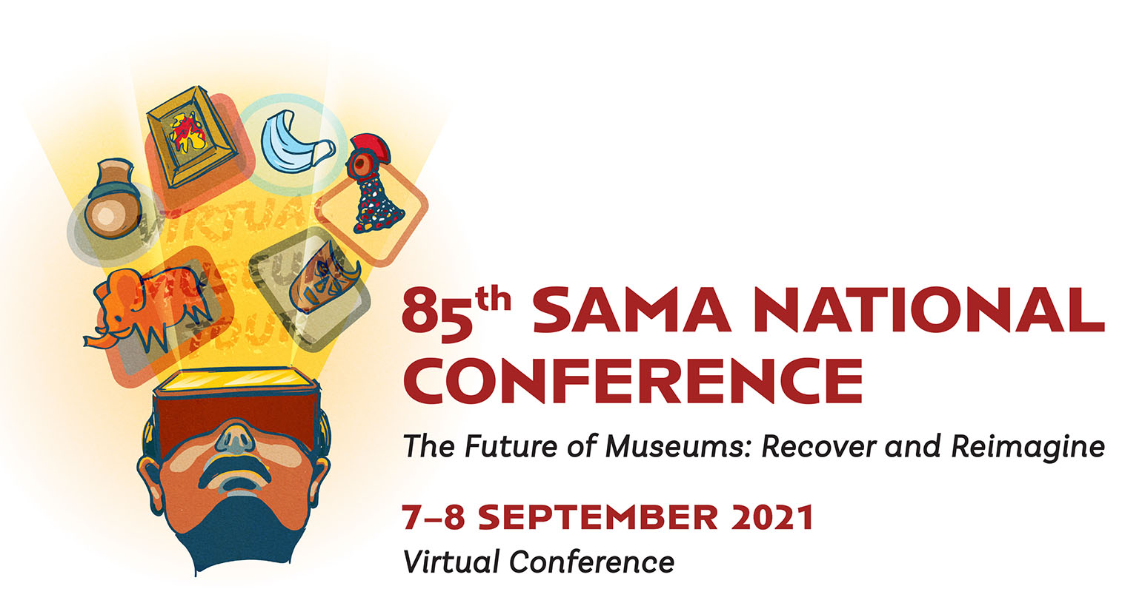
FINAL CIRCULAR
Manual registration form included in this document.

The 85th South African Museums Association 2021 National Conference will be held online on 7- 8 September 2021 from 10:00 – 16:00 daily. The theme is: “The Future of Museums: Recover and Reimagine.”
When the organising committee had to decide on a theme, the ICOM 2021 theme was a perfect fit, condensing all our emotions and struggles into a few words because we realized that the world has changed, and we need to recover and reimagine going forward.
The year 2020 has been like no other. The Covid-19 crises has swept the whole world abruptly, affecting every aspect of our lives, from interactions with our loved ones, to the way we perceive our homes and cities, to our work and its organisation. Some already pressing issues have been exacerbated, questioning the very structure of our societies: the call for equality is stronger than ever.
Museums are no exceptions to these changes, and the cultural sector is among the most affected: surveys conducted by ICOM and other international organisations present a dire situation for museums and their professionals, with serious economic, social and psychological repercussions in the short and long term alike.
This crisis also served as a catalyst for crucial innovations that were already underway, notably an increased focus on digitisation and the creation of new forms of cultural experience and dissemination.
This is a pivotal moment for our society, and we call museums to embrace it and lead the change. The time is now to rethink our relationship with the communities we serve, to experiment with new and hybrid models of cultural fruition and to strongly reaffirm the essential value of museums for the construction of a just and sustainable future. We must advocate for the creative potential of culture as a driver for recovery and innovation in the post-Covid era.
The theme: “The Future of Museums: Recover and Reimagine”, invites museums, their professionals and communities to create, imagine and share new practices of (co-)creation of value, new business models for cultural institutions and innovative solutions for social, economic and environmental challenges of the present.
Sources:
ICOM 18 May 2021 Communication Kit.
ICOM Bimonthly Digest from the Museum Network April-May 2021.

Registration
- The registration fee from 20 August 2021 is free
- Registration closes on 27 August 2021

- Please register for the conference:
- Manual registration – registration form on the next page.
Please complete and submit the registration form and send to Melissa Lindeque MelissaL@TSHWANE.GOV.ZA

- Please make a copy of this document available to colleagues who may wish to attend the conference/receive the conference circular.

- A link to attend the Conference will be send at the beginning of September 2021 to all delegates who have registered.

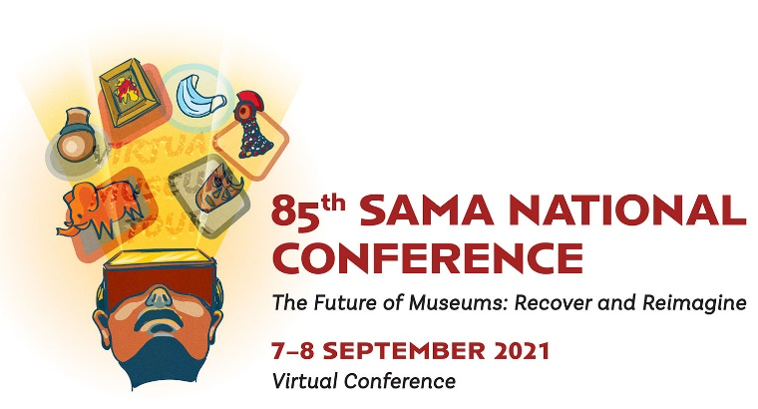
________________________________________________________________________

REGISTRATION FORM
Registration closes on 27 August 2021
I wish to attend the conference Date: _____August 2021
Title | First Name | Surname
Museum/Organisation |  | SAMA membership number (optional)
Contact number |  | Cell number:
Physical address |  | E-mail Address

Send your registration to:
Please complete and submit the registration form and send to:
to Melissa Lindeque MelissaL@TSHWANE.GOV.ZA
or Talita Fourie talitafourie13@gmail.com or talita.fourie@postoffice.co.za
or Fax to 086 560 4132
Registration closes on 27 August 2021

SIGNATURE | DATE
(Please make a copy of this available to colleagues who may wish to attend the
conference/receive the conference circular)
- A link to attend the Conference will be send at the beginning of September 2021 to all delegates who have registered.
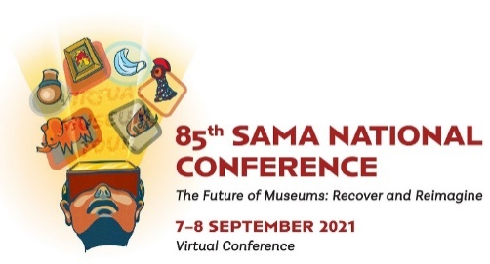
85th South African Museums Association National Conference
The Future of Museums: Recover and Reimagine
Conference Final Draft Programme
7- 8 September 2021
Daily from 10:00 – 16:00
Tuesday 7 September 2021
Session 1 Opening Session
Session Chair: Dr Bongani Ndlovu
09:45 | Sign in commences | All
10:00-10:05 | Welcome by SAMA North Chairperson | Talita Fourie
10:05 – 10:15 | Session Chair | Dr Bongani Ndlovu
10:15 - 10:25 | SAMA Presidential address | Dr Helene Vollgraaff
10:25 - 10:55 | Opening Address | Ms Mbali Hlope,  MEC Gauteng Department of Sports, Arts, Culture and Recreation.
10:55 – 11:35 | Keynote address  Recover and Reimagine: Becoming Beacons of Hope: The Future of Museums. | Dr Samuel Isaacs
Session 2 Presentations and discussions
The Future of Museums: Recover and Reimagine
Session Chair: Ishmael Mbhokodo
11:35 – 11:40 | Session Chair | Ishmael Mbhokodo
11:40 – 12:00 | The museums’ role in out-of-home entertainment. | Ms Sabine Lehman  Founder of Curiositas  AAVEA
12:00 – 12:20 | COVID-19 Pandemic – The Opportunity in the Crisis. | Ms Beulah Mosupye  Hauweng
12:20 – 12:40 | Museums as spaces for dialogue. | Mr Andre Croucamp  Totem Media
12:40 – 13:00 | Questions and answers
13:00 – 13:15 | Break
Session 3 Presentations and discussions
The Future of Museums: Recover and Reimagine
Session Chair: Tazneem Wentzel
13:15-13:20 | Session Chair | Tazneem Wentzel
13:20-13:40 | Museum Diversity in Africa: Museums, related exhibitionary institutions and non-state players. | Prof Jesmael Mataga  Sol Plaatjie university  Dr Thomas Thondhlana  Great Zimbabwe University  Prof Dawson Munjeri  Great Zimbabwe University
13:40-14:00 | Reinventing the interlinkage of museums and schools. | Dr Roger Layton  Roger Layton and Associates (RLA)
14:00-14:20 | COVID and Funding fiasco the Heritage Arts Cultural Sector Faces | Sir Nicolas Wolpe  The Lilliesleaf Trust
14:20-14:40 | Questions and answers
Panel discussion
Session 4 Presentations and discussion
The Johannesburg Manifesto and a Social Compact for Museums
Session Chair: Dr Jillian Carmen
14:40-14:45 | Session Chair | Dr Jillian Carmen
14:45-15:50 | The Johannesburg Manifesto and a Social Compact for Museums. | Dr Jillian Carmen  Emilia Potenza  Steven Sack
15:50-16:00 | Closure for day 1 | Talita Fourie
Wednesday 8 September 2021
Session 5 Presentations and discussions
The Future of Museums: Recover and Reimagine
Session Chair: Lemohang Zincume
09:45 | Sign in commences | All
10:00-10:10 | Session Chair | Lemohang Zincume
10:10-10:30 | Recovering and Reimagining: a constitutional vision. | Mr Francois Lion-Cachet  Constitutional Court Trust
10:30-10:50 | Cultural, node tourism defining the Drakensberg. | Ms Celeste Rossouw  The KwaZulu-Natal Amafa and Research Institute
10:50-11:10 | Practices and challenges in digital holocaust and genocide education: the case study of the Johannesburg Holocaust & Genocide Centre (JHGC). | Mr Mdudzi Ntuli  Johannesburg Holocaust & Genocide Centre  Mrs Catherine Boyd  Johannesburg Holocaust & Genocide Centre
11:10-11:30 | Questions and answers
Session 6 Presentations and discussions
Novice Speakers
Session Chair: Catherine Snell
11:35-11:45 | Session Chair | Catherine Snell
11:45-11:55 | The KwaZulu-Natal Museum Entomology Collection. | Ms Mandisa Ndlovu  KwaZulu-Natal Museum
11:55-12:05 | An overview of the collection of mollusks in the KwaZulu-Natal Museum. | Ms Nelisiwe Manukuza  KwaZulu-Natal Museum
12:05-12:15 | Workbench: A Tool in Specify to import Data. | Mr Siyabonga Zamisa  KwaZulu-Natal Museum
12:15-12:25 | Can Post-Covid era drive digitisation to digital transformation in the KwaZulu-Natal Museum. | Mr Matabaro Ziganira  KwaZulu-Natal Museum
12:25-12:35 | Questions and answers
12:35—12:50 Break
Session 7 Presentations and discussions
Governance
Session Chair: Ayanda Simelane
12:50-12:55 | Session chair | Ayanda Simelane
12:55-13:15 | Digitisation Policy | Mr Maano Muhadi  National Department of Sport, Arts and Culture.
13:15-13:35 | National Policy on the Repatriation and Restitution of Human Remains and Heritage Objects. | Ms Reinette Stander  National Department of Sport, Arts and Culture.
13:35-13:45 | Questions and answers.
13:45-13:55 | Conference closure. | Talita Fourie

14:00 South African Museums Association Annual General Meeting

South African Museums Association Presidential inauguration

Announcements
- Speakers – Dr Helene Vollgraaff
- Novice Speaker Award
- Fitzsimmons Award
- Presidential Award

- Design Awards – Lemohang Zincume
- Category A
Publications in book form (more than 4 pages) such as brochures, information booklets, annual reports, newsletters, monographs, exhibition catalogues, guides, educational resource material, etc. This division also includes educational posters and poster presentations.
- Category B
Publicity material or promotional material (less than 4 pages). Flyers, bookmarks, folders, floor plans, marketing posters, suites of material such as an advert, invitation, name tag, menu/programme for an event, or museum stationery letterhead, comps-slips, gift certificate, loan form, etc.
- Category C
Websites. For this division museums must submit a colour print of the site’s Home Page.

