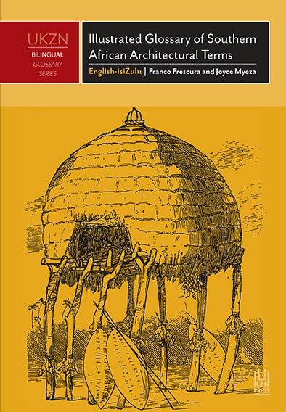
Ordering details:

Copies are available online from Loot: www.loot.co.za
Takealot: www.takealot.com
and Exclusive Books online:
www.exclusivebooks.co.za and at good bookshops.

Retail orders: Booksite South Africa

Telephone:
086 127 2273

e-mail:
orders@booksite-afrika.co.za

Illustrated Glossary of Southern African Architectural Terms
By Franco Frescura and Joyce Myeza

Since 1994 South Africa has undergone a steady erosion of its indigenous built environment, with a concomitant loss of indigenous building technology and its specialised terminology.
This glossary is based on the premise that you cannot understand the culture of a people unless you have a grasp of the nuances and hidden meanings of their language and brings together in one single volume the terminologies that are used by southern Africa’s rural builders. It covers the terminology used by indigenous builders as well as subsequent colonial white settlers including buildings of the so-called Cape Dutch, English Georgian, Victorian and Indian Traditions.

The text is set out in alphabetical order. It comprises each term in its original language, its translation where appropriate into isiZulu, and its definition in English and isiZulu. One of the strengths of this book is its visual component of accompanying sketches that expertly illustrate the terms.
This book is designed not only to assist in the teaching of architecture, but also to aid others who are interested in the field. Researchers and practitioners in disciplines such as anthropology, archaeology, culture studies and building science will find it a valuable addition to their libraries.
Franco Frescura was Professor and Chair of Architecture at the University of KwaZulu-Natal. He has published widely in the fields of indigenous architecture, colonial settlement and culture conservation. He has lectured in Europe, North America and South-East Asia. In 2010–2011 he was appointed Erasmus Mundus Scholar at the Technische Universität Darmstadt.
Joyce Myeza was a Fulbright Scholar at Simmons College, Boston. She is currently the Director of Libraries and Special Collections at the University of KwaZulu-Natal. Her current research interests include indigenous knowledge systems and enterprise architecture.
ISBN 978 1 86914 349 7
Price: R255.00
Interest: Architecture, indigenous knowledge, cultural studies
244 pp. Softcover.
245 x 170 mm
Publication Date: November 2016
Rights: World

Private Bag X01, Scottsville 3209, South Africa  Email: books@ukzn.ac.za | Tel: +27 (33) 260 5226 • Fax: +27 (33) 260 5801  www.ukznpress.co.za

