  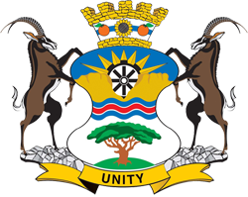 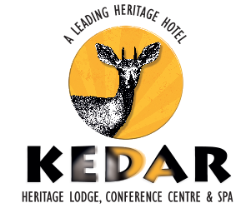 

**The North West to host the 2023 Heritage Symposium**

The next HASA Symposium will be held on 12th, 13th and 14th of October 2023; the venue will be Kedar Heritage Lodge located on the Boekenhoutfontein farm , about 20 kms from Rustenburg and an hour’s drive from Pretoria.

It’s going to be a brilliant heritage event **.**

A full programme is being planned by Donald Davies , in cooperation with Dr Mollie Moolman and Ds Stefan Botha of Rustenburg ( experts on Rustenburg Heritage) in association with the [Magaliesberg Association for Culture & Heritage](https://magaliesbergheritage.co.za/) (Chair Andre Wedepohl) and Mike Benn of MACH. We also enjoy the support of Kedar Lodge under the direction of Sarah Forsyth who are the custodians of the Boekenhoutfontein farm houses and museums

The full three-day event will comprise talks the HASA AGM s, excursions, the gala dinner, and HASA awards and to socialise with fellow heritage enthusiasts. Here is the opportunity to explore the rich heritage of Kedar and the Kruger family farmhouses , one of the finest private museums of Anglo Boer War memorabilia, the heritage heroes created by the late Robert Forsyth in his collection sculptures – Smuts, Rhodes , Gandhi, Churchill, de la Rey and many more.

We are planning **an enriching heritage programme** , including learning about platinum history with a mine and an historical tour of Rustenburg. We shall learn about life and times of Mzilikazi, engage the experiences and history of the Royal Bafokeng people., explore geological sites , dip into Lutheran church history and learn about the Anglo Boer War in this area. A game drive through the Kedar bushveld estate is an optional choice . There will be a guided visit to the Kruger family farmhouses.

Speakers will present talks in the morning – Thursday, Friday, Saturday and Outings will take place in the afternoons – Thursday, Friday Saturdays

Plus

**Thursday 12th Oct**  - ***Morning***  ***3 Talks***, ***Lunch*** , ***Afternoon Excursions*** : Kruger Farm houses and museums; Royal Bafokeng Cultural sites: ***Evening*** Welcome Braai and HASA AGM after from 19h30 to 21h 30

**Friday 13th Oct** - ***Morning***  ***3 Talks*** , ***Lunch*** , ***Afternoon Excursions*** – Olifants Dam Archaeological Site and/or Bakubung Platinum Mine and Boshoek Platinum Smelter***; Evening*** HASA gala award ceremony and dinner 18h30 – 21 h 30 at Kedar

**Saturday 14th October** - ***Morning 3*** Talks , ***Picnic Lunch*** at Kedar around pool ***Afternoon Excursions*** : Rustenburg Public architecture tour and Swart Ruggens tour and /or Pilansberg Game Reserve for Geological Tour and Game Drive; ***Evening***  final supper/ dinner with a key note speaker on Mzilikazi; on supper stage arrangement 18h 30 - 21h 00

***Book early*** to avoid disappointment – our capacity is 100 people. 50 places are reserved for HASA members and 50 for guests.

Speakers names and topics to be Advised.

**Background and essential information**

* **Rustenburg** has an interesting history. The area covered is the North West – a province of considerable cultural , religious, tourism and economic diversity
* **Kedar** is a country retreat, strong on heritage with a documented history that dates to the 19th century; there is an interesting grouping of the Boekenhoutfontein farmhouses demonstrating the evolution of South African vernacular farm architecture; there are five blue plaques under the auspices of MACH and an old family graveyard to explore.
* **Distance** Kedar is 2 hours’ drive from Sandton/Johannesburg and 1 hour 40 minutes from central Pretoria. It is 20 kms from Rustenburg on the Pretoria Road.
* **Kedar offers full conference facilities** and Sarah Forsyth, CEO of Kedar (following in the footsteps of her father, the late Robert Forsyth) is partnering with HASA and MACH to offer high quality excellent conferencing in the principal conference room at Kedar , the Campaign House .
* **Accommodation Options**. Attendees will have the choice of staying at Kedar or choosing a nearby alternative . Kedar offers single accommodation at R 1 144 per night inclusive of breakfast; or twin accommodation at R 1500 (2 people) per night inclusive of breakfast.
* You will need to book with Kedar for both accommodation and the symposium or if your choice is to stay elsewhere you will still need to book your conference place.
* Sun City , the Pilansberg and Rustenburg are popular tourist destinations so there are all types of accommodation to suit your pocket. Delegates to book their own accommodation at own cost.
* **Day attendance options** in addition to accommodation the conference attendance rate will be R 460 per day ie, R 1380 for 3 day conference inclusive of snacks and lunches and the venue hire.
* **Afternoon excursions** will be managed by self-drive and details to follow as part of our programme as we firm up speakers.
* **Game Drive at Kedar -** an early morning or sunset treat at Kedar Game reserve at R 250 per person
* **Target number** The Symposium will cater for at 100 guests each day.
* **Learning from the Past**. We shall line up with the best of recent past HASA symposiums at Hartbeespoort, Swellendam, Tulbagh, Barberton and Heidelberg and indeed 20 years of Symposium hosting.
* **Conference convenor** - Donald Davies , Chair of the Durban Art Deco Society is a construction engineer who recently relocated to Rustenburg.
* **The 2023 HASA AGM** will be held on day one, 12th October in the evening, giving our members the opportunity to participate in the planned Platinum mine tour.
* **10 conference talks/ lectures and choice of 3 expeditions from ( a choice of 2 per afternoon )** .
* **Own transport** to the Symposium and to visit heritage sites.
* **Bookstalls** There will also be bookstalls with a good heritage focus (new and old) and just good books.
* **Blue plaque** installation at a local heritage site.

Highlight topics for talks and expeditions.

* Geology and Archaeology
* Rustenburg in the Boer War
* Church and mission history
* Mining history – Platinum and the modern economy; mining labour history
* Land and the 19th century economy of the North West
* Platinum mining, labour issues and the modern economy
* The history of the Royal Bafokeng people and the women of Phokeng
* Mzilikazi in the Magaliesberg.
* The diversity of heritage in Bushveld and the Waterberg

Booking essential - please book via Kedar on the e mail / mobile

The Kedar Email to be used is: [kedaradmin@rali.co.za](mailto:kedaradmin@rali.co.za) ; the Kedar website is <https://kedar.co.za/>

Mobile Number: 071 858 4498.

Booking code: HASA

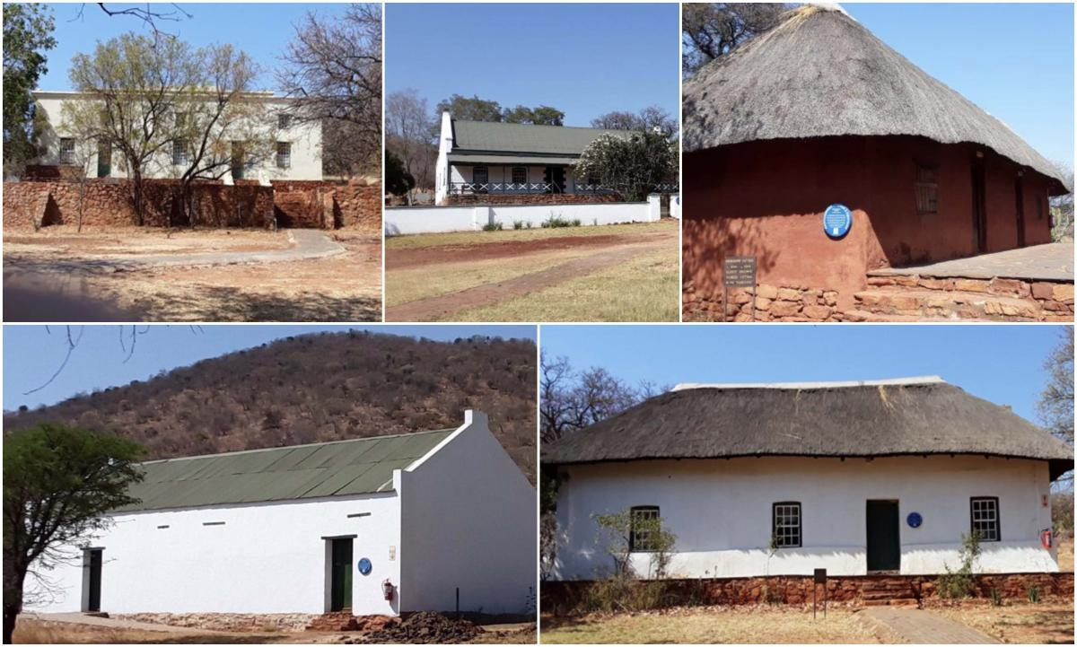

The farm houses of Boekenhoutfontein

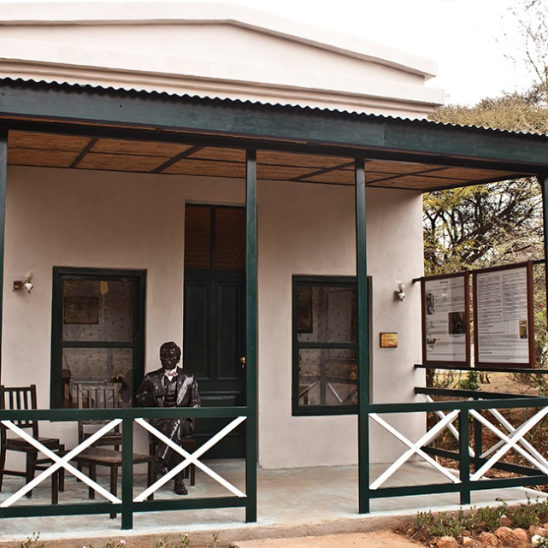

The Sol Plaatje memorial at Kedar Lodge

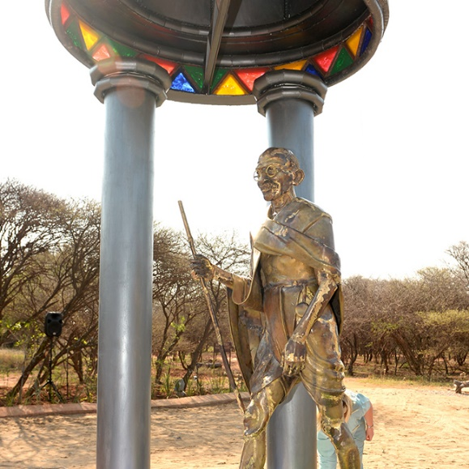

The Gandhi memorial at Kedar Lodge

**HASA Awards** -

We welcome nominations for Awards – both the Simon Van der Stel Gold Medal and the Heritage certificate awards – see details on the HASA website. <https://heritagesa.org/awards-nomination/>

Deadline end of July – submit to [info@heritagesa.org](mailto:info@heritagesa.org)’

Kathy Munro Chair of HASA

Donald Davies Symposium Organizer.

Andre Wedepohl for MACH .