#JoziWalks2018 taking place on the weekend 19th – 20th May

Walk My Joburg with #JoziWalks, a project initiated by the Johannesburg Development Agency (JDA)

#JoziWalks is a series of sponsored walking tours initiated in 2017 by the JDA in partnership with local community activists, tourism entrepreneurs, walking tour operators, and heritage specialists. #JoziWalks aims to get Joburgers onto the streets to walk and engage with neighbours and their local community, and to enable people to discover and share insights and ideas about the neighbourhoods they walk.
Led by a walk host these experiences are an opportunity to discover and give a voice to the stories of people who have shaped a community, and to kick start conversations about the achievements and challenges of a place. The walks are a chance to present a personal take on the culture, social history and development of a neighbourhood you know well. As an area-based development agency the JDA’s work has a vital social impact and the #JoziWalks initiative encourages conversation about possible local solutions to neighbourhood issues
Conditions to host a #JoziWalks2018
- The walks should be designed as a route, taking from one to three hours to complete (and held on both days where possible)
- Walks must combine elements of local culture, social history and encounters with people who are part of the local neighbourhood.
- The focus must be on communities, places and experiences
- Your walk must take place in an area where the JDA has a development presence or focus (See designated areas in Table 1)
- Each walk must be documented. Thereafter there will a competition, based on the submission of the documented portfolio of the walk (against defined criteria) for assessment. Prizes will be given for 1st, 2nd and 3rd place.

What #JoziWalks2018 is looking for

The ideal walk should:

1. Celebrate the real Joburg, the stories of places and people, and the spirit of the city

2. Foster community connection

3. Offer insights into what makes a neighbourhood work

Proposal submissions
To submit a proposal to host a walk, please complete the form below and email it to:
To submission your entry, the application forms must be completed and submitted via email by 5pm on Monday March 26 to:
- Douglas Cohen dcohen@jda.org.za and Langa Mancunga langa@lnmentertainment.co.za
Please note the closing date of 5pm on Monday March 26, 2018 is final.
If you need more detail, please attend a non-compulsory general information briefing held on Friday March 16 at 10:00am to 11:00am at the JDA offices at 3 Helen Joseph Street, Newtown.

Designated Areas: Places in an area where the JDA has a development presence or focus

Table 1: Applicable Joburg Neighbourhoods and Areas for #JoziWalk 2018
Inner City | Transit Nodes & Corridors | CBDs | Marginalised Areas
- Berea  - Braamfontein East and West  - Fordsburg, Vrededorp and Pageview  - Hillbrow  - Jeppestown, Bertrams and The Inner City Eastern Gateway (including Greater Ellis Park, Doornfontein, New Doornfontein, Troyeville, Lorentzville)  - La Rochelle, Turffontein and The Inner City South  - Newtown  - Yeoville | - Alexandra  - Auckland Park  - Brixton  - Jabulani  - Kliptown  - Milpark and Melville  - Nancefield  - Noordgesig  - Orange Grove  - Orlando East and West  - Westbury  - Westdene | - Lenasia CBD  - Randburg CBD  - Roodepoort CBD | - Diepsloot  - Ivory Park  - Orange Farm

Figure 1: Applicable Joburg Neighbourhoods and Areas for #JoziWalks2018
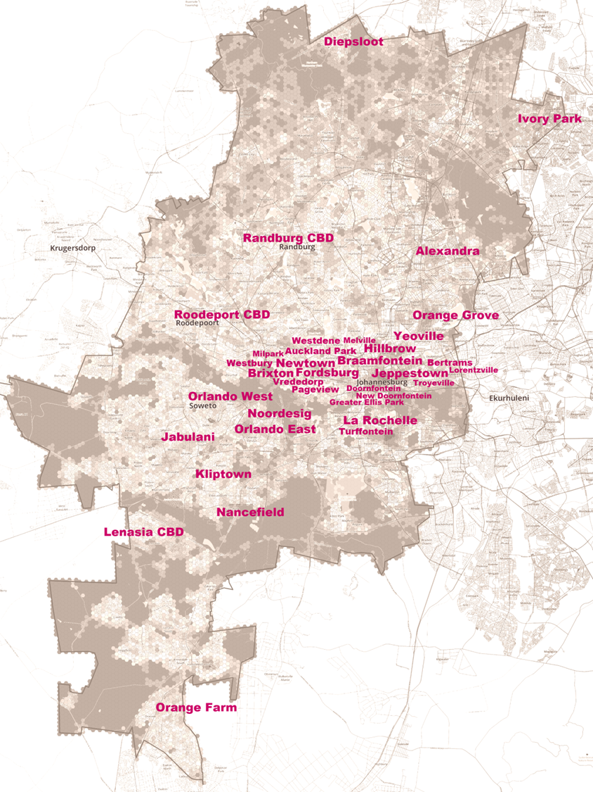
Please Complete all Sections

CATEGORY | DETAIL | ENTER YOUR RESPONSES IN THIS COLUMN
- Bidders details | Company / Organisation Name
 | Lead Person’s Name
 | Brief summary of lead’s person’s experience that is relevant to the proposed event / activity
- Contact details | Email
 | Cell
 | Land line
- Collaboration | Will you be working in partnership / collaboration with others for this event? If yes, please provide their details (name and contact details)
 | Organisation / person 1
 | Organisation / person 2
 | Organisation / person 3
- Event / Activity | Provide a name for your event / activity
 | Where in Joburg are you targeting for your event / activity? Please try specify area or suburb, precinct or neighbourhood.*  NOTE Walks must take in place in spaces /communities where the JDA has a development presence or focus. See Table 1 and places marked in pink on Figure 1. | *
Describe your event / walk

In your view what about visiting this community or place would make it a worthy or interesting (or special event) activity?
Describe who are the target participants and/or community for your event / activity? For example:
- Local residents
- Local businesses
- Community groups
- Cultural entities
- Youth / Elderly
- Artists
- Other Joburg residents
- Tourists
 | What would be your maximum number of participants that you can take on your walk?
 | When would you like to host the event / activity?  - Saturday and/ or Sunday  - Morning and/or Afternoon  Would it be possible to host on both days and/or timeslots? Please indicate this in the space opposite  Note, that walks will be a minimum of 1 hour and a maximum of 3 hours. | Saturday 19 May 2018 - AM
 |  | Saturday 19 May 2018 - PM
 |  | Sunday 20 May 2018 - AM
 |  | Sunday 20 May 2018 - PM
Local empowerment

Please suggest ways to work with and include local businesses, community members and any cultural entities along the route, to activate at least two spaces per route (at no cost for participants). The purpose is to encourage interaction with the spaces and the people who normally inhabit those spaces

Youth focus. Are you able to identify and include a local resident, young adult or media student to document the walk?
High-level proposal to manage safety and security during the event / activity.

If your bid is successful, you will be expected to confirm safety measures are in place

 | Please describe your walk / locations and or provide a MAP. The map can be hand drawn and must indicate starting and stopping points.
High-level proposal on event / activity logistics. Please identify for example:
- Start / End locations
- Gathering places or venues
- Toilets
Each successful walk application will receive R10,000 sponsorship to plan and implement a walk .

- How do you plan to make use of this budget in order to host your event / activity. Please give a breakdown of the intended use of funds.

Note, the budget must (at a minimum) cover water and a healthy snack for 30 participants in each walk (ideally refreshments should be locally sourced).
- Documenting the event / activity | The JDA regards #Joziwalks as an alternative approach toward understanding places and community through local feedback. What mechanisms will you put in place to successfully document your walk to share feedback?  This may include:  - Getting views of the participants - written/audio  - Images of places and people  - Artefacts  All bid hosts will be required to packaging their submission for presentation to the JDA (quality above quantity please) by June 1, 2018. Bid hosts must be available to attend the awards ceremony on at which you will present the outcome and experience. | Please confirm how / who will be documenting your event.
- PR and Marketing | How do you plan to successfully market your event / activity before, during and afterwards  For example:  - Using which local networks  - Social media  - Media  Co-branding is encouraged. | Please share details of these
- Risks | What possible risks do you foresee and how you plan to address them?  Please note that walkers will expected to sign Indemnity Forms provided by #JoziWalks and these must be returned with the project documents.
- Support | What support from the JDA would you like / expect in order for you to successfully host your event / activity?

