
City of Johannesburg

Arts, Culture and Heritage Services

IMMOVABLE HERITAGE INVENTORY FORM

Name of Site: The Indian War Memorial

Other Names (if any): The Indian Monument; South African Indian War Memorial.

Erf No.:

Street Address: At the Summit of Observatory Ridge, north of Bezuidenhout Valley. Access off Steyn Street.

District/Province/Region: Johannesburg: Gauteng

Ownership: City of Johannesburg

Site Type: War Memorial

Photos
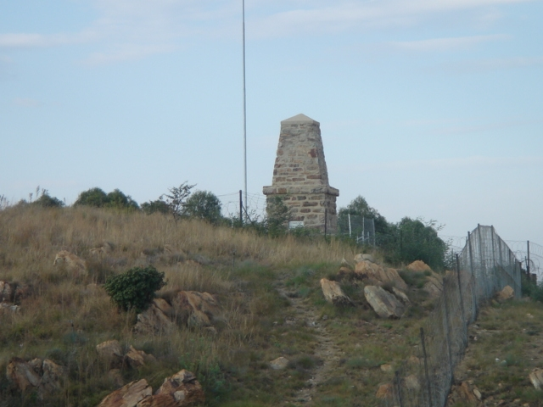
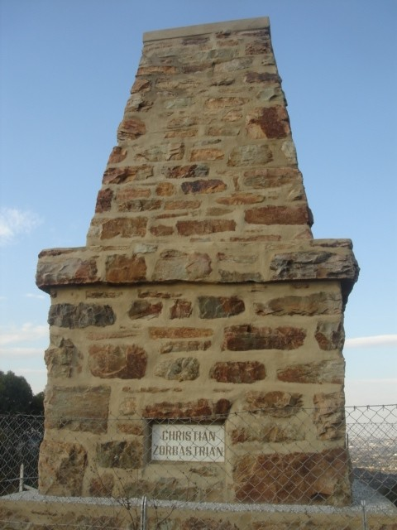

State of Conservation:

Good. The monument was restored in 2006, when the structure was re-grouted, re-pointed and sealed to prevent moisture retention. A lighting protection system was installed with an 18 metre high galvanized steel mast near the monument, to act as a lightning conductor.

The original marble tablets were smashed by vandals in the late 1980s. The panels were replaced by the War Graves and Graves of Conflict Division of the National Monuments Council. Of the original Urdu, Hindi and English translations, only the English remain.

Description:

The monument comprises a three metre tall sandstone obelisk cut from the sandstone of the ridge on which it stands. The site offers spectacular views of the eastern suburbs.

History:

The memorial commemorates the sacrifices of Indian auxiliaries who lost their lives during the Anglo-Boer War of 1899-1902. In total some 9 000 men were brought out from India to bolster the British forces. They took up non-combatant functions as stretcher- bearers, farriers (‘nalbands”) , veterinary assistants, grooms, orderlies, ammunition and water carriers and washermen.

An Indian detachment staffed a large remount camp in the valley below the memorial site, in what is now Bezuidenhout Park. Up to 4 000 horses could be accommodated at Bezuidenhout Valley’s large central remount station.

Indian troops camped in the valley on the south side of the ridege on which the Indian Monument was constructed. The campsite, in what was to become Observatory Park, was chosen mainly for its abundant water – needed by both men and horses – supplied by natural springs.

The first re-inforcements from India, about 1 000 men, arrived in South Africa in October 1899. By April 1900 more than 3000 Indians were involved in the war. With the Indian contingent came 2 334 horses and 611 mules and ponies and medical units comprising three complete field hospitals for British troops and one field hospital for their Indian orderlies. Breaking in and training horses was performed by the Indian auxiliaries.

The monument was initiated in the first flush of victory, during a suring of patriotic feeling which followed the end of the war. It was unveiled on 31 October 1902 by Hon. N.G. Lyttleton, the officer commanding the Transvaal and Orange River Colonies. Funding came partly from public subscriptions, with contributions from the local Indian community.

The Town Council Minutes of 29 October 1902 record the invitation to the unveiling ceremony:

“Captain J.CC. Perkins, the Native Oficers, N.C.O.s and men of the Indian Details, request the pleasure of the President and Members of the Johannesburg Municipality, their families and friends, to witness the unveiling of the Indian Monument at the Remout Depot, Bezuidenhout Valley, Johannesburg, by Lieut.-General the Hon. N.G. Lyttleton, K.C.B., commanding Transvaal and Orange River Colonies, at 3,45 pm on Friday, 31st October, 1902”.

Within a year of being erected , the monument was defaced by graffiti on the tablets. Acting swiftly, the town Council had the tablets cleaned and informed the government of the need to protect the monument. After surrounding the monument with an iron fence, the government handed the memorial over to the municipality. Care for the monument – previously the government’s responsibility – would henceforth be handed over to the Town Council.

Statement of Significance:

The Indian Memorial commemorates the little-known contribution of the Indian Army, which was the largest foreign contingent during the Anglo-Boer War. It is the oldest war memorial in Johannesburg, unveiled on 31 October 1902, five months after peace was declared.

The monument honours the role played by people of colour in what was officially held to be “a White Man’s War”. Aside from the Indian War memorial, the wartime contribution made by “Non-Europeans” was for many years overlooked and undervalued.

For South Africa’s Indian community, accompanied to discrimination from the country’s white rulers, the monument was a rare acknowledgement of Indian dignity. As reported in The Star on 1 November 1902, Indians from around the country welcomed the monument with delight:

“Telegrams have been received by the officer commanding Indian Details here from the Indian community, Cape Town, Hindu Siva Society, P.E., and the Indian Community, Durban, expressing gratification at the appreciation shown for the valour and loyalty of the Indian soldiers by the erection of a memorial which they acknowledge gives further proof of a truly Imperial Spirit in the hearts of all loyal subjects of his Majesty the King”.

Inscriptions:

[Tablet on the east side]

“To the memory of British Officers, Natives, NCOs and Men, Veterinary Assistants, Nalbands and Followers of the Indian Army”.

On the other three sides of the monument at tablets inscribed with the designationsa of the main religious groups involved:

“Mussulman [Muslim]”

“Christian – Zoroastrian”

“Hindu-Sikh”

Legal Status (Decree/Act):

Protected under Section 37 of National Heritage Resources Act: “public monuments and memorials must, without the need to publish a notice to this effect, be protected in the same manner as places which are entered in a heritage register …” As the Indian Memorial is older than 60 years, it is also protected in terms of Section 34 of the same Act.

Authority Responsible: SAHRA and City of Johannesburg

Use: War Memorial

Documentation/Research

X

Photos Maps Site Plans Others……………………………………

Source(s) of Information

- Itzkin, Eric. 2000. Gandhi’s Johannesburg: Birthplace of Satyagraha. Johannesburg: Witwatersrand University Press in association with MuseuMAfricA.
- Itzkin, Eric. 2003. The Indian War Memorial: Selective Memories of the Anglo-Boer War. Africa Quarterly, vol. 43, no. 2, 2003.
- Johannesburg Town Council Minutes (71st Meeting), 29 October 1902.

Name & Address of Recorder:

Eric Itzkin. City of Johannesburg, Dept. of Arts, Culture and Heritage, no. 2 President St., Joburg Newtown Building, Newtown. P.O. Box 517, Newtown, 2113.

Position:

Deputy Director: Immovable Heritage

Signature Date

26 September 2007

