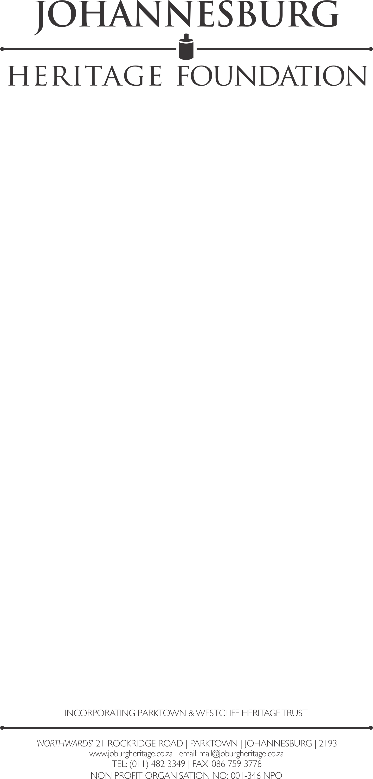

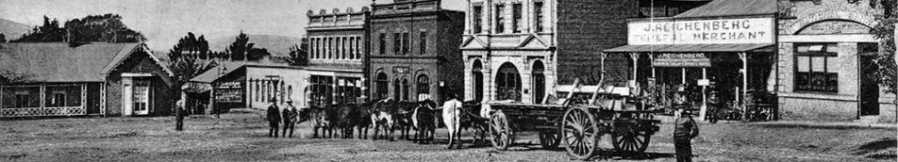

OUT OF TOWN TOUR: HEIDELBERG AND THE VAL DISTRICT

6 - 8 OCTOBER & 13 - 15 OCTOBER

David Forrest invites you to join us on an exploration of Heidelberg and The Val District. We start in Heidelberg, where local guide Bouwe Wieseman and his team will show us the heritage of Heidelberg, including the 151 year old Klipkerk. We then make our way to the farming district where Ludwig Ankiewicz explains why the region is so exceptional.

Our next stop is the relatively unknown hamlet of Val, and we will be staying at the lovely Val Hotel. Over the next two days, we will explore the fascinating History of Val and Villiers with stories of very colourful characters and stops at monuments of some very interesting and unusual historical events, we will even make a stop at our guide Ludwig’s farm.

We finish off the tour with a stop in Balfour where we will visit the exquisite Welgelegen Manor, for a finger lunch and a fascinating tour of this beautifully restored Sir Herbert Baker mansion, which was once home to the Mostert Family.
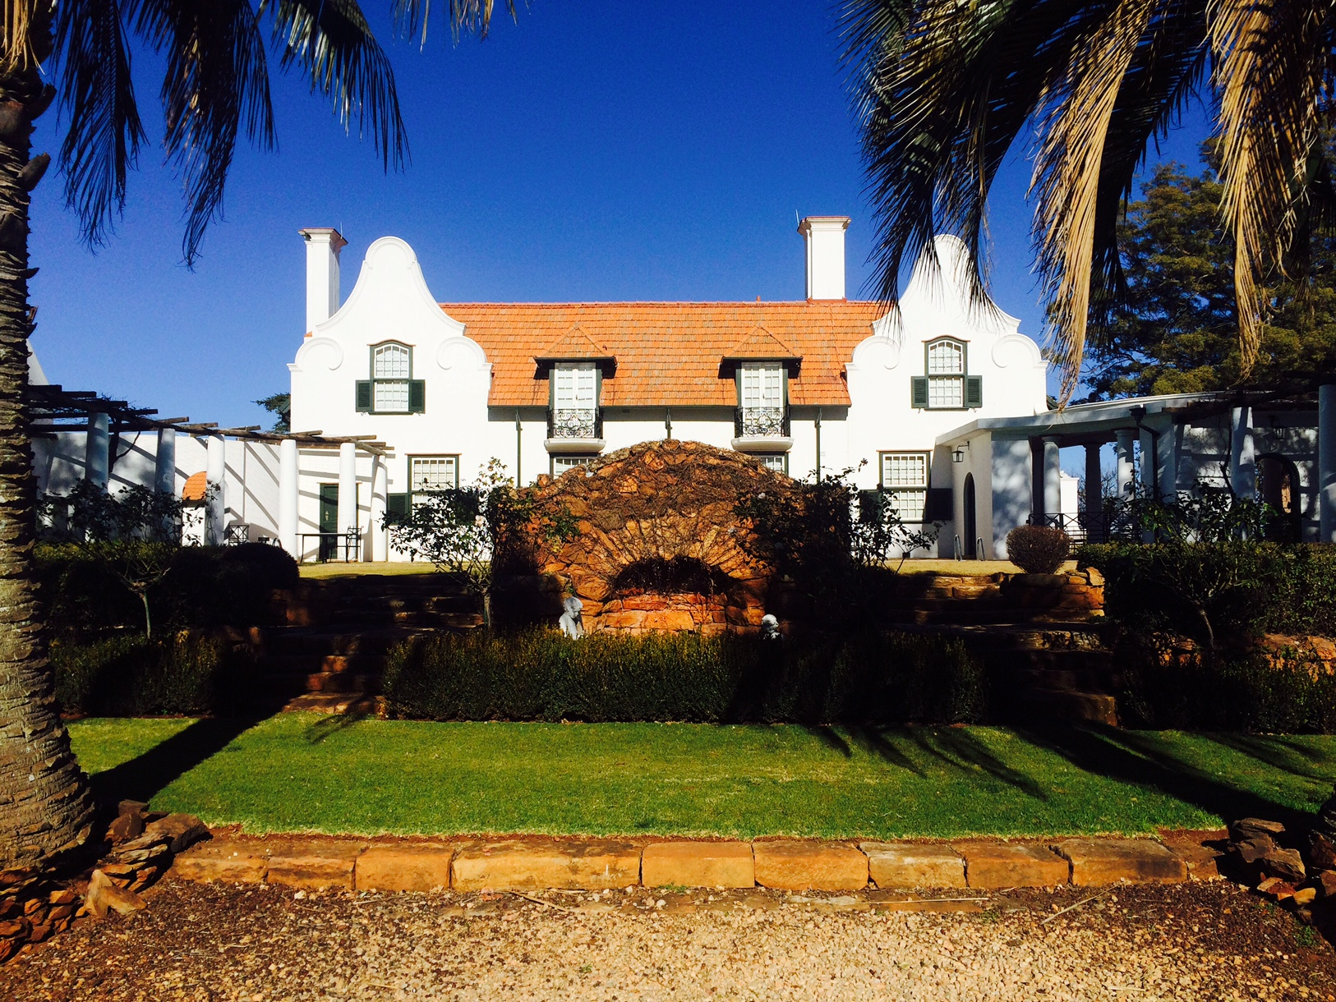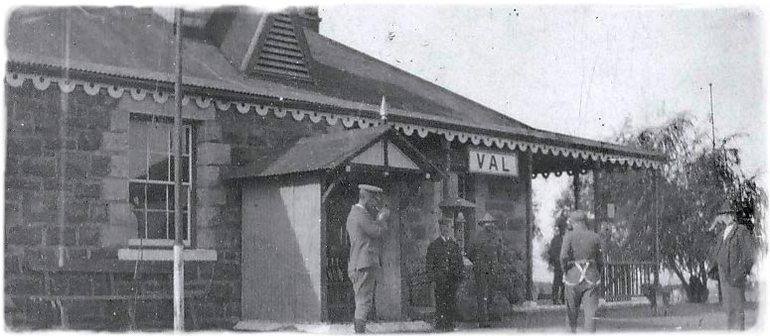
Cost: R3,000 per person sharing, with a single supplement of R500
(all inclusive, except drinks!)

BUS TOUR
‘MAGICAL MODDERFONTEIN’

SATURDAY, 21st OCTOBER

Modderfontein owes its existence to the discovery of gold and the need for explosives manufacturing, but despite its origins in heavy industry It has a distinctive "village atmosphere". Many of the century-old buildings are still in use today, including some with strong Anglo-Boer war connections. Add to this many interesting personalities and there is a recipe for a fascinating exploration of a Johannesburg suburb.
We will be using a bus to get us to the parts of Modderfontein usually off limits to us, and our tour includes the cemetery, compound and plant.
And as always, we will be guided by Modderfontein expert Keith Martin, ably partnered by Clare van Zwieten.
GUIDES : Keith Martin and Clare van Zwieten
TIME : 14h00
PARK : Sunnyside Park Hotel
COST : R200.00 for members and R260.00 for non-members –
which includes a donation to the Modderfontein
Conservation Society
DURATION : Approximately 3 hours
MAXIMUM No: 60
-----oOo-----

WALKING TOUR
‘STARSTRUCK IN URANIA VILLAGE’

SATURDAY, 28th OCTOBER

Johannesburg’s historic Observatory occupies the highest point in the city and commands magnificent views of the city and its suburbs and, of course, the cosmos! There is much of architectural interest. The original wood and iron director’s house is probably the oldest building, but there are three Baker gems too: the original observatory, the elegant library, and the director’s house.
We start our tour of this historic corner of Johannesburg at the Observatory, where we will explore the SAIEE Museum and have access to the telescope room.
We then meander down Urania Road to view homes from Observatory’s golden period, including a magnificent art deco Mediterranean villa designed on the eve of the stock market crash by Issy Wayburne that is rumoured to have had a role in the anti-apartheid struggle.
Our tour ends back at the Observatory, where patrons will be able to purchase refreshments to enjoy for lunch in glorious May sunshine.
GUIDES : Monique Jefferson McDonald and Prof Katherine Munro
PARK : The Observatory, 18A Gill Street, Observatory
TIME : 10h00
DURATION : 3 hours
COST : R90.00 for members and R150.00 for non-members –
which includes a donation to the Urania Village
Residents Association
MAXIMUM No: 60

Food and drink will be on sale – so be sure to bring cash!

-----oOo-----

ILLUSTRATED LECTURE
‘THE HELL WHERE YOUTH AND LAUGHTER GO’
From the Tyranny of Rhetoric to the Vocabulary of the Real

SUNDAY, 5th NOVEMBER

One hundred years ago, on the 11th of November 1917, an agreement signed between the Allies and Germany at Compiègne, France, formally marked the cessation of hostilities on the Western Front of World War I. In the preceding three years, 18 million military personnel and civilians lost their lives, and 23 million were left wounded, ranking World War I among the deadliest conflicts in human history. After the horror of the trenches, the optimism and opulence of the Belle Epoque was inconceivable, and the brave new modern world was born.
In “The hell where youth and laughter go - from the tyranny of rhetoric to the vocabulary of the real” Dr Neil Viljoen explores the importance of language and image in shaping opinion and in expressing the horror and tragedy of the conflagration. This illustrated lecture runs the gamut from propaganda posters to poetry, and from the music hall to the concert hall.
HOST : Dr Neil Viljoen
PARK : Northwards, 21 Rockridge Road, Parktown
TIME : 14h00
DURATION : 2 hours
COST : R90.00 for members and R150.00 for non-members
MAXIMUM No: 60
-----oOo-----

BUS TOUR
‘DUBE’

SATURDAY, 11th NOVEMBER

Armistice Day has been chosen especially for our first tour of the historic Dube Township where, after the Second World War, two hundred small cottages were built for soldiers who had volunteered and been on active service.
We start with unveiling a plaque to Theo Mthembu - the boxer turned trainer - who included Baby Jake among the champions he trained. We visit the SA Legion's Hall to remember the men who served in two World Wars. And our tour ends with tea at the YWCA which is associated with Ellen Kuzwayo and other famous women with struggle credentials.
This is a bus and walking tour so wear comfortable shoes and hats.
GUIDES : Flo Bird and Tshenolo Ballito and Cheche Selepe
PARK : Sunnyside Park Hotel, 2 York Road, Parktown
TIME : 13h00 – please note early start time
DURATION : 4 hours
COST : R200.00 for members and R300.00 for non-members
MAXIMUM No: 60
-----oOo-----

WALKING TOUR
‘VERY DOWNTON ABBEY – GLENSHIEL AND ITS NEIGHBOURS’

SUNDAY, 12th NOVEMBER

Sir William and Lady Dalrymple are the closest thing to royalty this rabble town ever got. In 1908 they commissioned Herbert Baker to design a home high on the Westcliff ridge. Baker and his partner Fleming’s response was Glenshiel, an imposing butterfly-wing residence. So palatial were the stables, that when the house was gifted to the Order of St.John by Major Haggie, he simply converted them into a substantial home for himself.
One of the first homes to have a swimming pool and tennis courts, Glenshiel was the set for glittering parties and distinguished guests, including Princess Alice, Countess of Athlone, granddaughter of Queen Victoria.
We are privileged to have access to the interior to admire the panelling and rather grand hall, but for many the highlight of the visit will be the garden where, if the hail hasn’t damaged them, you can scent the roses from the terrace.
Our tour starts at the Ridge School (originally the Woolsack and home of Sir Aubrey Woolls-Sampson) which has fine views south, and then proceeds via Glenshiel to Pallinghurst. Now the Hope School, it is an extraordinary Gothic concoction quite unlike any other building in Johannesburg, and with magnificent views over Zoo Lake.
Then back up a rather steep hill to The Stables, lovely gardens and a house which has evolved with time from housing horses to some much more distinguished residents.
GUIDES : Adam Golding and John-John de Castro
PARK : The Ridge School, Woolston Road, Westcliff
TIME : 10h00
DURATION : 3 hours
COST : R90.00 for members and R150.00 for non-members
MAXIMUM No: 50
-----oOo-----

WALKING AND BRUNCH TOUR
‘IN SEARCH OF GAM SAAN – AN EXPLORATION OF CHINATOWN’

SATURDAY, 18th NOVEMBER

The forefathers of today’s Chinese South Africans came here in search of Gam Saan, “the Gold Mountain”. Some came as labourers, but many were traders, and they established a vibrant Chinatown on the western end of Commissioner Street. One family who came to this country as merchants still runs a business in Old Chinatown – the Sui Hing Hong supermarket.
It is today run by Mr Walter Pon in a building on the north side of Commissioner Street. Mr Pon’s parents fled China in the wake of the Japanese invasion in the 1930s, and he was born in Sophiatown in 1940. His father opened the shop three years later, naming it after his mother.
Today, Sui Hing Hong is the oldest remaining shop in Old Chinatown, and is treasure house of Chinese products.
Our tour begins with the traditional Cantonese brunch, Yumcha, where we will enjoy tea and dim sum on the ground floor of one of Johannesburg’s architectural marvels, Pabst’s Chinese United Mansions. Mr Pon will then lead us through an illustrated history of Chinatown, and we will end our tour in Sui Hing Hong supermarket, where you can shop at your leisure!
This is a tour not to be missed!
GUIDES : Mr Walter Pon and Brett McDougall
PARK : 1 Fox Street parking
TIME : 10h00
DURATION : 2.5 hours
COST : R150.00 for members and R220.00 for non-members, including
Yumcha
MAXIMUM No: 40
-----oOo-----

WALKING TOUR
’IN THE FOOTSTEPS OF KALLENBACH AND GANDHI’

SUNDAY, 26th NOVEMBER

This is a walking tour through the hilly countryside of Sylvia Pass, Kallenbach Drive, and Linksfield Ridge in search of the footprints left by the German-South African architect, Hermann Kallenbach, and his great friend Mohandas Gandhi. Kallenbach made a unique contribution to the Johannesburg townscape – in a series of religious, commercial and residential buildings, and as a township developer in the north-eastern suburbs. But it is the decade where he and Gandhi shared a friendship and a political struggle in this City, between 1903 and 1914, that was perhaps the most significant in his life.
The top of Kallenbach Drive, the steep pass that bears the architect’s name, is one of Johannesburg’s most magnificent view sites. We shall examine his stonework on the retaining walls, steps and boundaries, and also learn a bit about the geology of this important ridge which dominates Orange Grove, Sydenham and Linksfield to the north. A highlight of the tour is a visit to the meditation stones on the site of Kallenbach’s home.
We will be expertly led by Professor Kathy Munro and local historian and author of In the Footsteps of Gandhi, Alkis Doucakis.
We start and end at Sylvia's Market - if you want to explore the market arrive early, or stay on for lunch and music.
Note this is a walking tour: you need good shoes, sun block, sun hat and water. It's a challenging walk so a reasonable level of fitness is required, as we shall be walking down Sylvia Pass and then back up to the top of the ridge via Kallenbach Drive.
GUIDES : Prof Katherine Munro and Alkis Doucakis
PARK : Sylvia’s Market, 59 Frederick Street, Observatory
TIME : 09h30
DURATION : 3 hours
COST : R90.00 for members and R150.00 for non-members
MAXIMUM No: 50
-----oOo-----

ILLUSTRATED TALK
’13 BUILDINGS – 13 PERSONALITIES’

SATURDAY, 2nd DECEMBER

In a remarkably short 13 decades, Johannesburg has developed from a ramshackle mining camp into a bustling metropolis. Its rich and complex built and social history, unrivalled in sub-Saharan Africa, is reflected in an eclectic and diverse streetscape, and a cosmopolitan citizenry.
Brian Kent McKechnie and Brett McDougall explore the making and shaping of the city through the lens of 13 iconic buildings and 13 influential personalities, covering its evolution from an Uitlander imposition in the heart of the Zuid Afrikaansche Republiek, to a respectable outpost of the British Empire; from a City infatuated with American popular culture, to one that increasingly looks to Dubai and Shanghai for inspiration.
GUIDES : Brett McDougall and Brian McKechnie
MEET AT : Northwards, 21 Rockridge Road, Parktown
TIME : 14h00
DURATION : 2 hours
COST : R90.00 for members and R150.00 for non-members, including
tea and biscuits
MAXIMUM No: 60
-----oOo-----

WALKING TOUR
’THE MYSTERY AND DELIGHT OF JOHANNESBURG’S ARCADES’

SATURDAY, 9th DECEMBER

Johannesburg used to be a City of Arcades. They were an attractive investment to property owners, maximising valuable retail space, and a boon to shoppers, providing them with protection from the elements and the dirt and dust of City streets. Our Victorian and Edwardian arcades were charming: delicate cast iron structures supporting a glass roof canopy, the floors often exquisitely tiled. Almost all were lost in the rush to modernise and to make investments pay, but one survived this carnage.
Hidden between bustling Gandhi Square and a forgotten corner of Fox Street, Somerset House was boarded up by the United Building Society and used to house safety deposit boxes, its checker-board floor and green art-nouveau tiles lost to view. But now, through the vision of Gerald Olitzki who has revived nearby Gandhi Square, Fox Street and much beyond, it is being returned to its former glory.
We are privileged to be able to visit historic Somerset House on a tour that explores the City’s arcades. This is a tour not to be missed!
GUIDES : Flo Bird and David Gurney
PARK : The Carlton Centre Parking – meet at the Gandhi Statue on
Gandhi Square
TIME : 14h00
DURATION : 3 hours
COST : R90.00 for members and R150.00 for non-members
MAXIMUM No: 50

BOOKINGS CAN BE MADE THROUGH COMPUTICKET EITHER AT A COMPUTICKET OUTLET OR ON-LINE. WHEN BOOKING TICKETS, PLEASE USE EXACT NAME OF TOUR AS IT APPEARS ON THE PROGRAMME

FOR COMPUTICKET TELEPHONE BOOKINGS: (011) 340-8000

WHEN PAYING CASH PLEASE ALWAYS ENSURE THAT YOU HAVE THE CORRECT AMOUNT. IT WASTES TIME IF TOUR LEADERS HAVE TO GIVE CHANGE

BANKING ACCOUNT DETAILS – JOHANNESBURG HERITAGE FOUNDATION, NEDBANK PARKTOWN, ACCOUNT NO 1944023011 BRANCH CODE 194405

TOURS ARE SUBJECT TO CHANGE WITHOUT NOTICE

FOR QUERIES CONTACT OFFICE ON TEL NO (011) 482-3349 (WEEKDAYS 9AM – 1PM) OR SEND AN E-MAIL TO mail@joburgheritage.co.za

